*Florida International University*

*School of Computing and Information Sciences*

CIS 4911 - Senior Capstone Project

Software Engineering Focus

Final Deliverable

Project Title: SkillCourt 4.0

**Team Members:**

Luis Puche

Sebastien Dolce

**Product Owner(s)**:

Gumi Traustason

Jaime Borras

**Mentor(s)**:

N/A

**Instructor**: Masoud Sadjadi

The MIT License (MIT)

Copyright (c) *2016 Luis Puche, Sebastien Dolce*

Permission is hereby granted, free of charge, to any person obtaining a copy of this software and associated documentation files (the "Software"), to deal in the Software without restriction, including without limitation the rights to use, copy, modify, merge, publish, distribute, sublicense, and/or sell copies of the Software, and to permit persons to whom the Software is furnished to do so, subject to the following conditions:

The above copyright notice and this permission notice shall be included in all copies or substantial portions of the Software.

THE SOFTWARE IS PROVIDED "AS IS", WITHOUT WARRANTY OF ANY KIND, EXPRESS OR IMPLIED, INCLUDING BUT NOT LIMITED TO THE WARRANTIES OF MERCHANTABILITY, FITNESS FOR A PARTICULAR PURPOSE AND NONINFRINGEMENT. IN NO EVENT SHALL THE AUTHORS OR COPYRIGHT HOLDERS BE LIABLE FOR ANY CLAIM, DAMAGES OR OTHER LIABILITY, WHETHER IN AN ACTION OF CONTRACT, TORT OR OTHERWISE, ARISING FROM, OUT OF OR IN CONNECTION WITH THE SOFTWARE OR THE USE OR OTHER DEALINGS IN THE SOFTWARE.

***Abstract***

*In current day, there are a lot of methods of training soccer players. The current systems of training, however, are downright primitive and usually require a field, an instructor, a team and an array of costly elements. Anyone that does not possess these things faces sub-par training.*

*SkillCourt plans to alleviate these requirements through the use of technology. It offers a massive improvement over traditional methods due to personalized sequences and interactions.*

*This document summarizes the requirements, functional and non functional of a SkillCourt Backed system. All established by the product owners Gumi Traustason and Jaime Borras*

**Table of Contents**

**Introduction**

Current System

Purpose of New System

**User Stories**

Implemented User Stories

Pending User Stories

**Project Plan**

Hardware and Software Resources

Sprints Plan

*Sprint 1*

**System Design**

Architectural Patterns

System and Subsystem Decomposition

Deployment Diagram

Design Patterns

**System Validation**

**Glossary**

**Appendix**

Appendix A - UML Diagrams

*Static UML Diagrams*

*Dynamic UML Diagrams*

Appendix B - User Interface Design

Appendix C - Sprint Review Reports

Appendix D - Sprint Retrospective Reports

**References**

# Introduction

SkillCourt is currently on version 4.0, previous versions included a lot of different functionality. However, due to limitations of previous versions as well as with the thought of new ideas, alterations to the older versions had to be developed. The fact is that it is much better to move from a decentralized to a more centralized system.

## Current System

SkillCourt 3.0 is based around Processing IDE. The system operates through a single connected pad which communicates serially through USB. For operation to occur, events are generated by the software and translated into serial commands.

The pads which communicate which SkillCourt 3.0 come in two varieties: Master and Slave. The master pad has a bluetooth sensor which communicates with the Android application. The android application is the one that initiates the events followed. Because of this, bluetooth, android and a computer are required to operate.

The system uses force sensors to detect when the pad has been interacted with and for the ball to bounce off it. Pads are small, and not physically tough enough to actually kick yet. It is limited as well in the fact that only one pad is usable as well that the way it is designed, the local system is difficult to secure.

## Purpose of New System

SkillCourt 4.0 is a movement in a different direction. It replaces the current system for a java standard that can be ran in any type of IDE. The porting to the new version allows for the creation of a new way of handling SkillCourt into a more concrete standard. Functionality can now be expanded through the use of Java libraries. As seen with OpenGL and XML type outputs.

Additionally, the original version as modified to the point where multiple pads can now be simultaneously connected as well as the creation of an iOS app for a wider audience. An XML sequence standard was also developed for future versions to use.

# User Stories

User stories centered around the design of future-proofing a system and creating something that could be better designed and used by a consumer. This meant adding additional functionality to the current system, while keeping in mind the limitations. The creation of a new type of centralized system being a necessity and requested by the product owners to avoid future limitations as well as an iOS app.

It is worth noting that creating a strong foundation for future systems was one of the mentioned priorities This was however, not the first mentioned priority, originally the request was to create an android game. Instead, work was pushed towards the development if the system instead. For this, a modular design was chosen, whilst not neglecting in adding functionality to the original.

## Implemented User Stories

**User Story # 653 - Create an Android Game Main menu**

Description:

* As a user, I would like to be able to access a main menu in android for the game. So that users can have a way to access to the game’s main functions.

**User Story # 661 - Create a SkillCourt Sequence Standard**

Description:

* As a user, I would like to create a standard for stored sequence files to be used throughout skillcourt. So that functionality to create and modify SkillCourt stored sequences becomes possible.

**User Story # 655 - Interpret and load simulation standard into virtual simulator**

Description:

* As a user, I would like to be able to load and interpret the established simulation standard into a virtual simulator so that users can have sequences loaded for operation and simulation.

**User Story # 672 - Create custom-sized grids**

Description:

* As a SkillCourt owner, I would like to be able to define custom sizes for tile grids. So that I can create a skill court of any size.

**User Story # 676 - Communicate to multiple pads**

Description:

* As a SkillCourt owner, I would like to be able to communicate to multiple pads. So that games can be physically executed.

**User Story # 683 - Custom Grid Viewer**

Description:

* As a SkillCourt owner I would like to be able to load custom views from grids. So that a user can visually interact with any type of grid.

**User Story # 692 - SkillCourt Sequencer Wizard**

Description:

* As a SkillCourt owner, I would like to be able to create sequences in an easy format. So that a user or owner can create sequences in an easy-to-use format.

**User Story # 654 -iOS user registration**

Description:

* As a user,I should be able to register to the SkillCourt system

**User Story # 659 - iOS user login**

Description:

* As a registered user,I should be able to login to the SkillCourt system

**User Story # 666 - iOS view and edit profile**

Description:

* As a user I should be able to view and edit my profile

**User Story # 675 - iOS persistent data**

Description:

* As a user I should be able to save data locally in order to use offline

**User Story # 678 - iOS save user option**

Description:

* As a user I should be able to decide whether or not to save my info locally

**User Story # 682 -iOS logout**

Description:

* As a user, I should be able to logout of the SkillCourt system

**User Story # 687 -iOS sequence creation**

Description:

* As a user, I should be able to customize and export my own sequences

**User Story # 696 -iOS connect to SkillCourt Bluetooth**

Description:

* as a user I should be able to connect to the SkillCourt Pads through bluetooth so that I can run my drills from my App

**User Story # 699 -iOS view and edit teams**

Description:

* as a user I should be able to view my team as well as add players to my team so that I can monitor progress

# Project Plan

Due to the hardware heavy nature of SkillCourt, very specific materials are needed for skillcourt to operate properly no matter which version. The changes made to SkillCourt and chosen plan reflect the inherent need for standardization and a solid foundation for future versions.

## Hardware and Software Resources

Much of the hardware was selected by engineering teams, other was chosen because it was available. As for software, the solutions are standard and the most popular online, providing decent documentation instead of using obscure libraries. A shift into standardization to what is available out there.

**Hardware**

* System: Windows 7 Ultimate - 64 bit
  + 4 GB RAM
  + 2.0 TB Disk Space
  + Nvidia 260 GTX
* Arduino Uno
* Breadboard and other electrical
* Force sensors
* Arduino bluetooth interface
  + HM-10 bluetooth module
* USB Hub
* Samsung Galaxy S5
* iPhone 5s (iOS 8.1)

**Software**

* NetBeans IDE 8.0.2
* 64-bit RXTX 2.1 Java Library
* Lightweight Java Game Library 2.0
* Mac OS X el Capitan
* OpenGL Nifty GUI Engine 1.4
* Processing IDE 3.0.2
* xCode 6.1 or higher
* Android Studio 2.0
* Notepad++ 6.9
* Microsoft Office
* Arduino 1.6.8

## Sprints Plan

### Sprint 1

(01/18/2016 - 1/29/2016)

**User Story # 653 - Create an android game Main Menu**

***Tasks***

* #691 - Create Icons

***Acceptance Criteria***

* Visible main menu options
* Include three menu options
* Slick2d as a game engine

***Modeling***

Class Diagram in ---------------- Appendix fig 101

Use Case in ---------------------- Appendix fig 201a

Sequence Diagram in ----------- Appendix fig 201b

**User Story # 654 -iOS user registration**

***Tasks***

* #660 -create project
* #664-link app to parse
* #665-setup view controllers

***Acceptance Criteria***

* Require minimal info
* Will push data to parse
* Will run on any iphone 8.1 or higher

***Modeling***

Class Diagram in ---------------- Appendix fig654a

Use Case in ---------------------- Appendix fig654b

Sequence Diagram in ----------- Appendix fig654c

### Sprint 2

(02/1/2016 - 02/12/2016)

**User Story # 661 - Create a SkillCourt Sequence Standard**

***Tasks***

* # 657 - Develop Primitive tester.
* # 658 - Develop Interpreter.
* # 662 - All SkillCourt Objects serializable.

***Acceptance Criteria***

* XML format output of files.
* All Objects must be serializable.
* Able to export files and interpret.

***Modeling***

Class Diagram in ---------------- Appendix fig 102

Use Case in ---------------------- Appendix fig 202a

Sequence Diagram in ----------- Appendix fig 202b

**User Story # 659 - iOS user login**

***Tasks***

* #663 -setup view controller

***Acceptance Criteria***

* Require username and password
* Will authenticate
* Will display four tabs upon login

***Modeling***

Class Diagram in ---------------- Appendix fig 659a

Use Case in ---------------------- Appendix fig 659b

Sequence Diagram in ----------- Appendix fig 659c

### Sprint 3

(02/15/2016 - 02/26/2016)

**User Story # 655 - Interpret and load simulation standard into virtual simulator.**

***Tasks***

* # 656 - Develop File Format
* # 657 - Develop Primitive Tester.
* # 658 - Develop Interpreter.

***Acceptance Criteria***

* An interpreter which works with the virtual standard.
* Running code with the simulator
* Simulation standard java interpreter.
* Running simulator tested and working.

***Modeling***

Class Diagram in ---------------- Appendix fig 103

Use Case in ---------------------- Appendix fig 203a

Sequence Diagram in ----------- Appendix fig 203b

**User Story # 666 - iOS view and edit profile**

***Tasks***

* #667 - prepare database
* #668- code upload method
* #669- test methods
* #670- reduce image size

***Acceptance Criteria***

* User will have option to upload image
* Images have to be saved a data

***Modeling***

Class Diagram in ---------------- Appendix fig 666a

Use Case in ---------------------- Appendix fig 666b

Sequence Diagram in ----------- Appendix fig 666c

### Sprint 4

(02/29/2016 - 3/11/2016)

**User Story # 672 - Create custom-sized grids**

***Tasks***

* # 690 - Create a Grid-info object.

***Acceptance Criteria***

* Ability to run a simulation with any grid size.
* Response through the simulator.

***Modeling***

Class Diagram in ---------------- Appendix fig 104

Use Case in ---------------------- Appendix fig 204a

Sequence Diagram in ----------- Appendix fig 204b

**User Story # 675 - iOS persistent data**

***Tasks***

* #702 - setup data model
* #703- setup managed object context

***Acceptance Criteria***

* Should work when app launches
* Should occur upon login

***Modeling***

Class Diagram in ---------------- Appendix fig 675a

Use Case in ---------------------- Appendix fig 675b

Sequence Diagram in ----------- Appendix fig 675c

### Sprint 5

(03/21/2016 - 04/01/2016)

**User Story # 676 - Communication to multiple pads**

***Tasks***

* # 677 - Create a serial-handler class.

***Acceptance Criteria***

* Communication to more than one pad at the time.
* Existence of a SerialPadHandler Class.
* Control of pad LEDs and other basic functions.

***Modeling***

Class Diagram in ---------------- Appendix fig 105

Use Case in ---------------------- Appendix fig 205a

Sequence Diagram in ----------- Appendix fig 205b

**User Story # 678 - iOS save user option**

***Tasks***

* # 704 - tabs in app as well as in iphone settings app must be created

***Acceptance Criteria***

* Must have save user option
* Must also be in settings bundle

***Modeling***

Class Diagram in ---------------- Appendix fig 678a

Use Case in ---------------------- Appendix fig 678b

Sequence Diagram in ----------- Appendix fig 678c

**User Story # 682 -iOS logout**

***Tasks***

* Setup method in settings tab

***Acceptance Criteria***

* Button in settings page
* Logs out of parse
* Return user to login page

***Modeling***

Class Diagram in ---------------- Appendix fig 682a

Use Case in ---------------------- Appendix fig 682b

Sequence Diagram in ----------- Appendix fig 682c

### Sprint 6

(04/04/2016 - 04/15/2016)

**User Story # 683 - Custom grid view**

***Tasks***

* # 684 - Instate LWJGL with Nifty-gui
* # 685 - Create XML handler class.
* # 686 - Create a simple Nifty Service.

***Acceptance Criteria***

* Creation of buttons matching grid size and arrangement.
* GUI visually created using Nifty-GUI
* Export of Nifty-GUI xml file
* Creation of a virtual display object which can be called on demand.

***Modeling***

Refer to UML diagrams in Appendix A that were created or modified to model the functionality that will be implemented in this sprint.

**User Story # X - Story Name**

Class Diagram in ---------------- Appendix fig 106

Use Case in ---------------------- Appendix fig 206a

Sequence Diagram in ----------- Appendix fig 206b

**User Story # 687 -iOS sequence creation**

***Tasks***

* # 705 - create sequence encoding algorithm
* # 706 - create wizard for user

***Acceptance Criteria***

* Must generate xml file

***Modeling***

Class Diagram in ---------------- Appendix fig 687a

Use Case in ---------------------- Appendix fig 687b

Sequence Diagram in ----------- Appendix fig 687c

### Sprint 7

(04/18/2016 - 04/29/2016)

**User Story # 692 - SkillCourt Sequencer Wizard**

***Tasks***

* # 692 - JOptionPane Interface.
* # 694 - RXTX Interface.
* # 695 - Visual run and load sequences.

***Acceptance Criteria***

* A main menu with relevant buttons.
* Proper fields, steps for NEXT and final creation of sequence.
* Export and loading of sequence files through UI.

***Modeling***

Class Diagram in ---------------- Appendix fig 107

Use Case in ---------------------- Appendix fig 207a

Sequence Diagram in ----------- Appendix fig 207b

**User Story # 696 -iOS connect to SkillCourt Bluetooth**

***Tasks***

* # 698 - setup delegates
* #697- import CoreBluetooth library

***Acceptance Criteria***

* Must only connect to SkillCourt pads
* User friendly

***Modeling***

Class Diagram in ---------------- Appendix fig 696a

Use Case in ---------------------- Appendix fig 696b

Sequence Diagram in ----------- Appendix fig 696c

**User Story # 699 -iOS view and edit teams**

***Tasks***

* # 700 - setup table views
* #701- setup delegates

***Acceptance Criteria***

* Should display player pool
* Should display player images

***Modeling***

Class Diagram in ---------------- Appendix fig 699a

Use Case in ---------------------- Appendix fig 699b

Sequence Diagram in ----------- Appendix fig 699c

# System Design

The design of SkillCourt is heavily influenced by the hardware as well as recommendations from players. It is to give insight to architectural parameters. Skillcourt is divided into different sub-systems. Modularly developed to allow the re-use and preprogramming of needed details in later development.

## Architectural Patterns

For SkillCourt, the architectural pattern used was an MVC (Model View Controller). This also involves user interaction so that the user can create and manipulate data with as much flexibility as the program itself. For example here with a sequence diagram of one of the stories using MVC model  
  
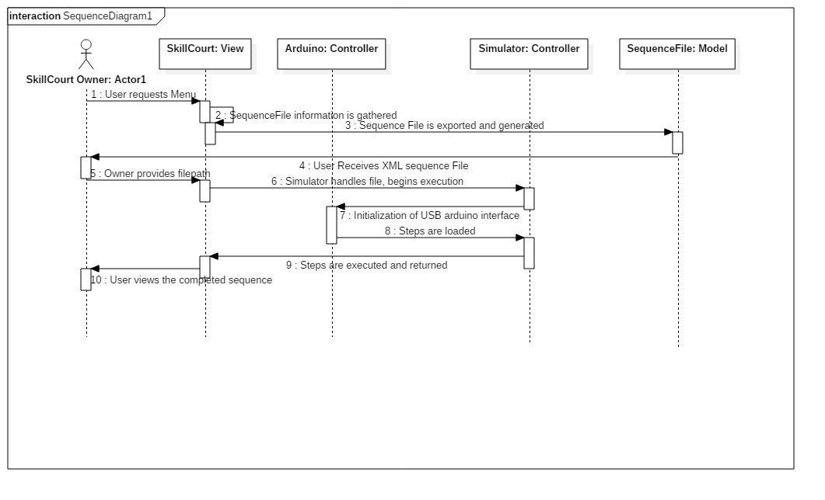

*Figure 1 - MVC as seen in sequence Diagram.*

## System and Subsystem Decomposition

Systems and subsystems were created with modifications and the future in mind. They can all work independently and provide functionality for specific things by themselves. Of course they are divided into a main 4.

Briefly describe the functionality provided by each subsystem:

**Sequence Subsystem (Models):**  This sub-system holds most of the models of grids, pads, gridInfo and everything that represents a physical item in a live preview.

**Simulation Subsystem (Controllers):** Operates and handles virtual and live simulations. In order to keep it re-usable. It will only handle the internal logic, only what happens within the processor not outside of it. It is what allows local testing of sequences without the need for anything external.

**Communication Subsystem(Controllers):** Handles and operates all the types of communications to the pads. It is expandable in the form that we’re not limited to just USB but also ethernet in the future.

**View Subsystem:** Anything that a user is meant to interact with, that is the GUI, the application or the wizard fall under this system. It operates in OpenGL which is compatible in all types of systems as long as dll extensions are available for user. It handles everything to do with visual libraries, UIs and direct user interaction.

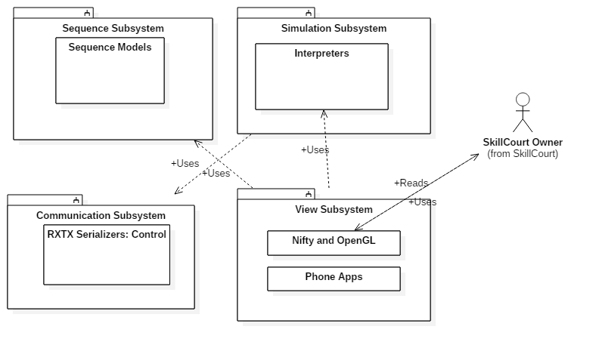

*Figure 3 - Subsystems of v2*

## Deployment Diagram

Using a UML deployment diagram, illustrate which subsystems will reside on each hardware component and show how the different pieces are connected.

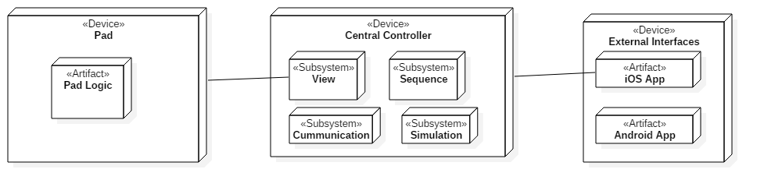

*Figure 3 - Deployment Diagram*

As viewed here, the Central controller keeps most of the subsystems keeping the requests from external devices and pads light. All logic, even to the web are to be controlled by the central controller. Modification to his controller is what will occur in the future.   
  
The controller is the one that communicates with the app as well with the pads. Directly. Pads have their own logic. However it is only used in a reactionary way to a command sent by the Central controller. The only communication a pad should send is the force sensor if triggered and a confirmation.

## Design Patterns

Design patterns used by SkillCourt sequencer include creational patterns such as prototype in order to create sequence files in a valid form to be exported. If this pattern was not used there would be a problem related to XML export and serialization

Another design pattern used through the application has been in the behavioral side. Interpreters for example handle XML login into live Serial commands. Interpreting a recorded sequence into a serial event. Iteration was actually a necessity as well, in order to follow through each step and each stage of the sequence.

Behavioral states have been added to know if a sequence has been executed. Command requests were used in a way as serial commands are in itself an object created. Proxies as well. The gridInfo class is a lightweight representation of the Grid class. Which for the sake of a sequence file. Is not needed on that complexity.

# 

# System Validation

The system was validated with both manual and automated tests. Executions were ran to the software so that the whole functionality could be tested and improved on. Netbeans provided ease in testing tools as well as naturally Android code is java based and could be tested as well.

**User Story # 653 - Create an Android Game Main menu**

System Tests

* Test ID UC653_01 - Standard Loading of main menu, sunny day.
* Test ID UC653_02 - Opening the main menu when already open, rainy day.

Subsystem Tests

* Test ID UC653_03 - Basic display on GUI

**User Story # 661 - Create a SkillCourt Sequence Standard**

System Tests

* Test ID UC661_03- Test the export as an XML file

Subsystem Tests

* Test ID UC661_01- Test the getting of grids in a valid sequence file.
* Test ID UC661_02- Test the getting of Steps in a valid sequence file.
* Test ID UC661_04- Test the getting of information in a valid sequence file.

**User Story # 655 - Interpret and load simulation standard into virtual simulator**

System Tests

* Test ID UC655_01 - To test the loading of an XML file
* Test ID UC655_02 - To test the loading of an XML file - No file found

Subsystem Tests

* Test ID UC655_03 - To test the creation of file without parameters.

**User Story # 676 - Communicate to multiple pads**

System Tests

* Test ID UC676_04 - Test the full link and communication with a pad.

Subsystem Tests

.

* Test ID UC676_01 - Test the creation of a com object
* Test ID UC676_02 - Test the creation of a com object, invalid params
* Test ID UC676_03 - Test the creation of a com object, out of bounds params

**User Story # 683 - Custom Grid Viewer**

System Tests

* Test ID UC683_01 - Test the creation of a grid, sunny day. All params good
* Test ID UC683_03 - Test the creation of a grid, rainy day. Overflowed rows.

Subsystem Tests

* Test ID UC683_02 - Test the injection of invalid parameters.

**User Story # 692 - SkillCourt Sequencer Wizard**

System Tests

* Test ID UC692_03 - Test the complete creation, loading and running of a sequence. Through UI

Subsystem Tests

* Test ID UC692_01 - Test the loading of a valid created sequence.
* Test ID UC692_02 - Test the loading of an invalid created sequence.

**User Story # X - Story Name**

System Tests

* Test ID - Brief statement of the test purpose.
* …

Subsystem Tests

* Test ID - Brief statement of the test purpose.
* …

**User Story # X - Story Name**

System Tests

* Test ID - Brief statement of the test purpose.
* …

Subsystem Tests

* Test ID - Brief statement of the test purpose.
* …

**User Story # 654 -iOS user registration**

System Tests

* SkillCourt-unit-register-001-Test if user is in database after enetring valid info
* SkillCourt-unit-register-002-Test if method handles user already registered
* SkillCourt-unit-register-003-Test if method handles invalid email

Subsystem Tests

* SkillCourt-integration-register-004-Test if loginview appears at successfull registration

**User Story # 659 - iOS user login**

System Tests

* SkillCourt-unit-login-001-Parse rejects invalid info
* SkillCourt-unit-login-002-Test if isvalid true and successful login
* SkillCourt-unit-login-003-Test if invalid with all blank fields

Subsystem Tests

* SkillCourt-integration-settings-login-004-Test if alert view appears if info invalid
* SkillCourt-integration-logins-005-Test if tabs appear upon login

**User Story # 666 - iOS view and edit profile**

System Tests

* SC-ProfileViewController-UT-002-test if picture will show up when selected
* SC-ProfileViewController-UT-003-test if error message appears when picture does not save

Subsystem Tests

* SC-ProfileViewController-UT-001-Test if the method returns the ImageViewController upon pressing the Edit Photo button

**User Story # 675 - iOS persistent data**

System Tests

* SkillCourt-integration-data-001-Test if user details are locally saved for faster access
* SkillCourt-integration-data-002-Test if method ignores the saving when invalid login occurs

Subsystem Tests

* SkillCourt-unit-data-001-Test if saved with valid login info
* SkillCourt-unit-data-002-Test if saved with invalid login info

**User Story # 678 - iOS save user option**

System Tests

* none

Subsystem Tests

* SkillCourt-unit-settings-001-Test if loginViewController can read a true settings bundle option
* SkillCourt-unit-settings-002-Test if loginViewController can read a false settings bundle option
* SkillCourt-unit-settings-003-Test if setting can change from false to true from open app
* SkillCourt-unit-settings-004-Test if setting can changed from true to false from open app

**User Story # 682 -iOS logout**

System Tests

* SkillCourt-unit-logout-002-Test if logout function leads to the login page

Subsystem Tests

* SkillCourt-unit-logout-001-Test if logout fuction clears the currentUser object

**User Story # 687 -iOS sequence creation**

System Tests

* SkillCourt-unit-sequence-001-Test if xml file is created with correct info
* SkillCourt-unit-sequence-002-Test if xml file is created with incorrect time info

Subsystem Tests

* None

**User Story # 696 -iOS connect to SkillCourt Bluetooth**

System Tests

* SkillCourt-unit-bluetooth-002-Test if error message when bluetooth not found
* SkillCourt-unit-bluetooth-003-Test if error message when device bluetooth is off

Subsystem Tests

* SkillCourt-unit-bluetooth-001-Test if device discovers peripherals

**User Story # 699 -iOS view and edit teams**

System Tests

* SkillCourt-unit-team-001-Test if list of players displays properly
* SkillCourt-unit-team-003-Test if team list displays properly

Subsystem Tests

* SkillCourt-unit-team-002-Test if empty list appears

# Glossary

Define any domain-specific terms that the audience of this document may be unfamiliar with. You can assume the audience of this document to be technical savvy. Examples of terms that do not need to be defined are: HTML, CSS, Web Server, DB, and the like.

# Appendix

## Appendix A - UML Diagrams

### Static UML Diagrams

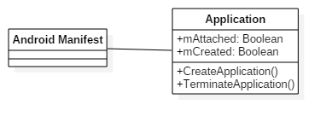

*Figure #101 - Class Diagram for Android Game Menu (653)*

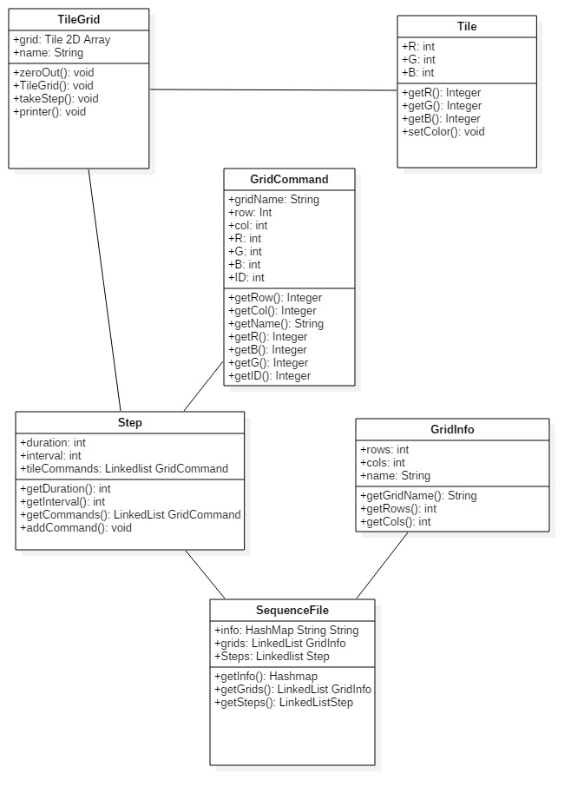

*Figure #102 - Class Diagram for creation of sequence standard (661)*

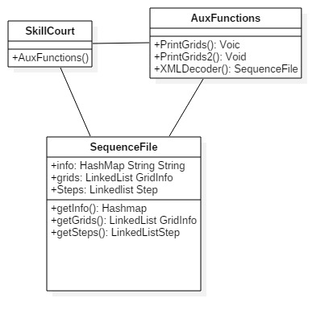

*Figure #103 - Class Diagram for Interpreter (655)*

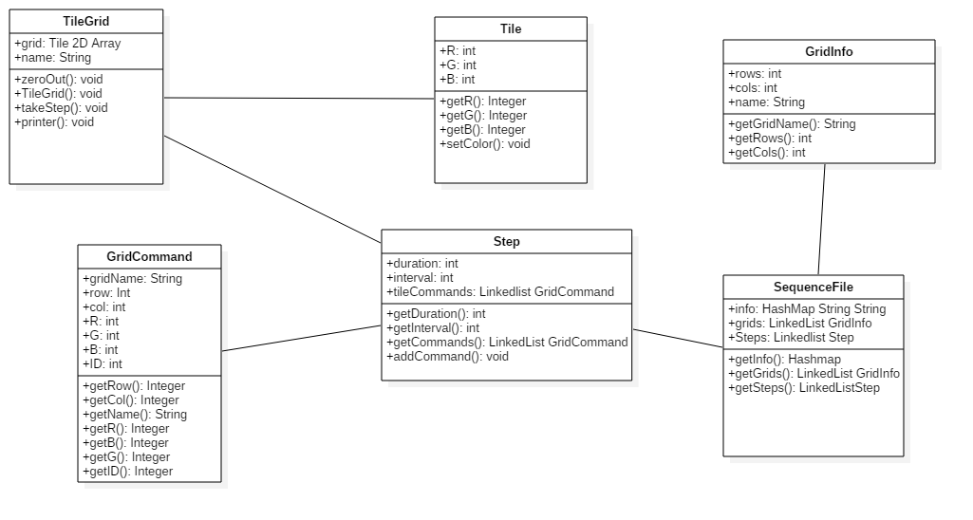

*Figure #104 - Custom Sized Grid Process (672)*

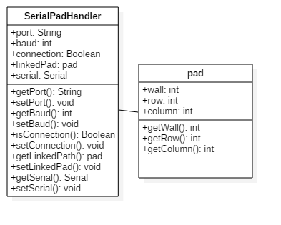

*Figure #105 - Class Diagram for Serial Communication (676)*

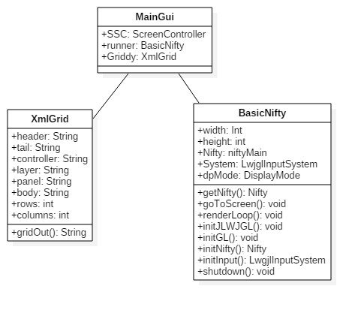

*Figure #106 - Class Diagram Custom Grid View (683)*

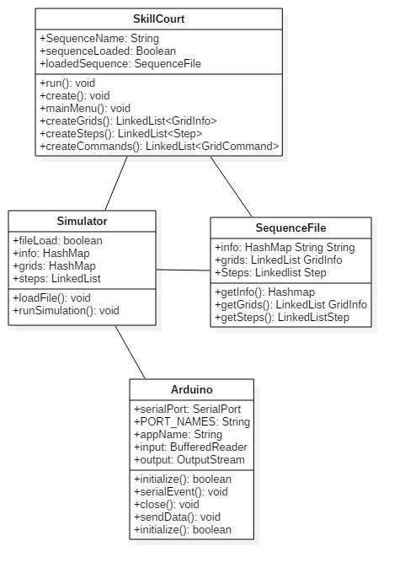

*Figure #107 - Class Diagram SkillCourt GUI Wizard (692)*

### 

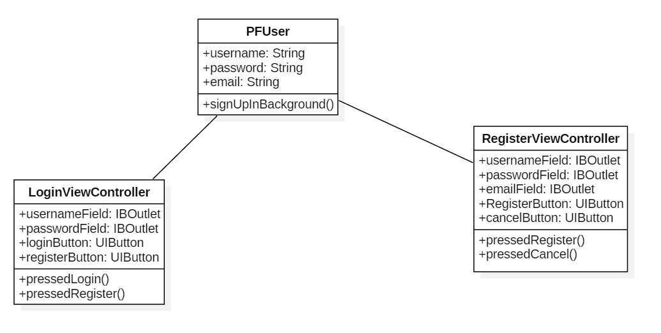

*Figure #654c - Class diagram- regster (654)*



*Figure #655c - class diagram- login (655)*

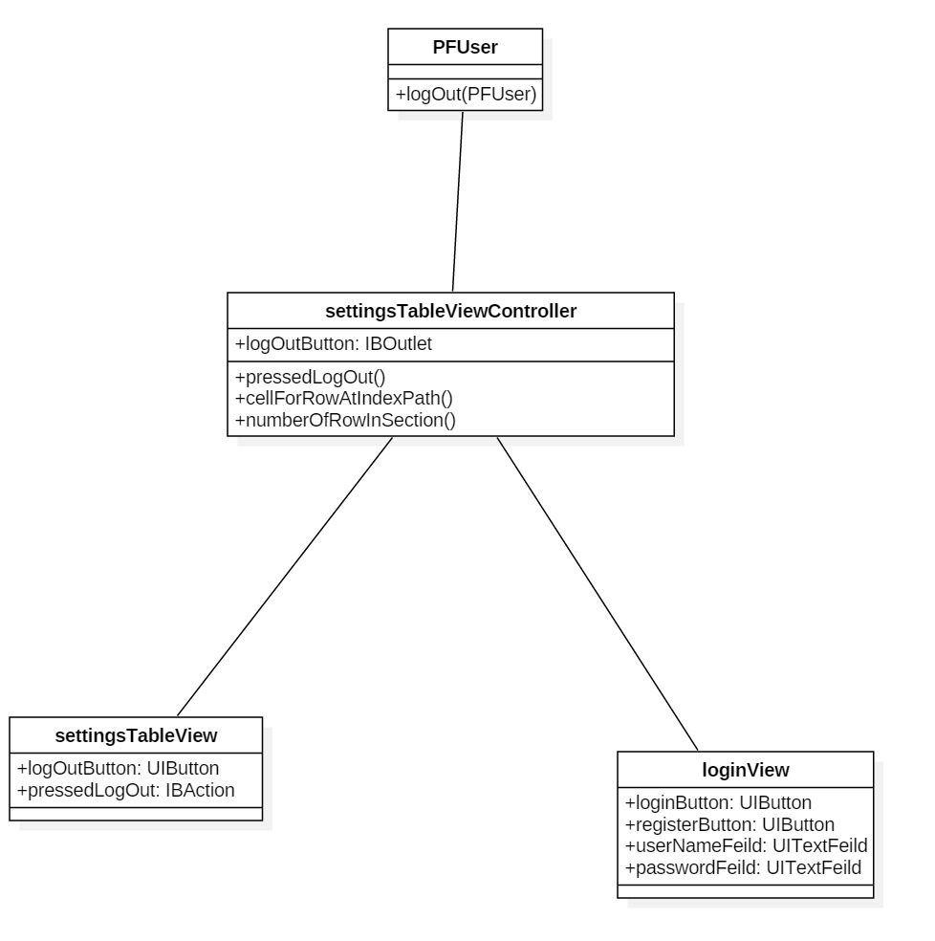

*Figure #682c - Use case diagram- logout (682)*

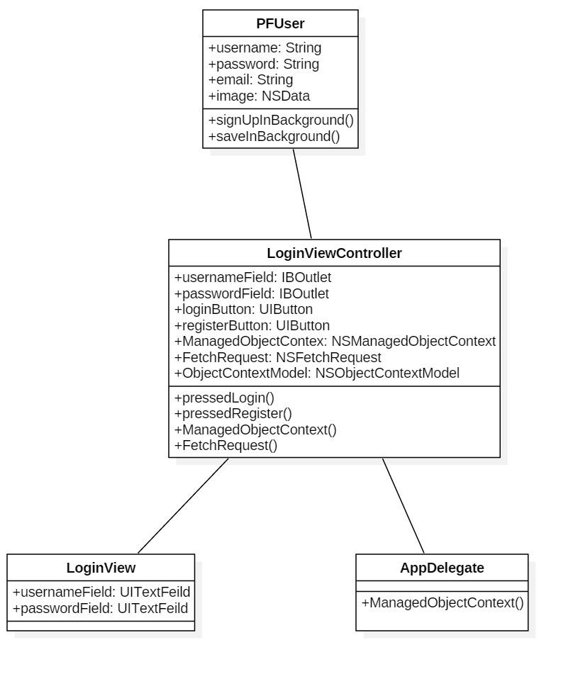

*Figure #675c - class diagram- save (675)*

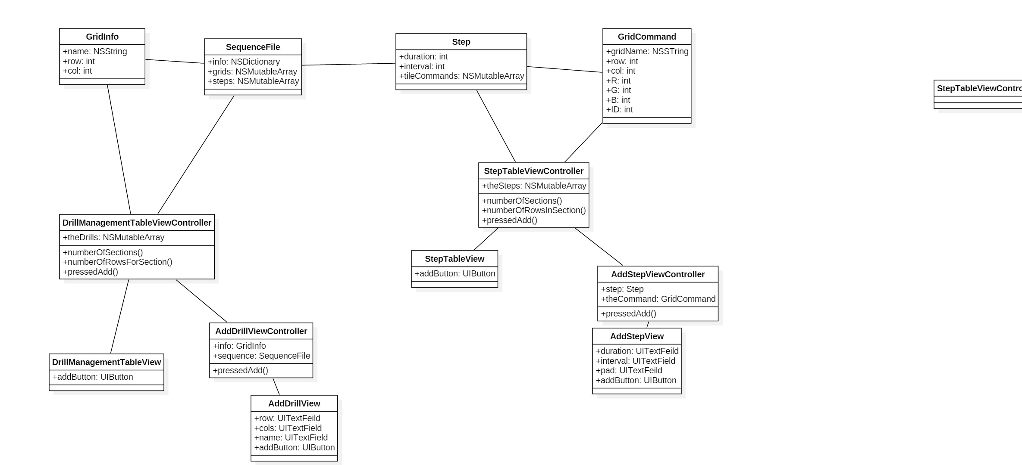

## 

*Figure #687c - class diagram- sequence (687)*

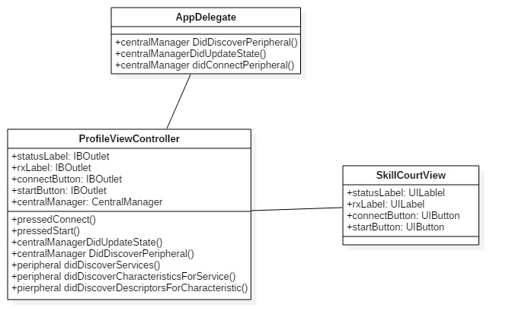

*Figure #696c - class diagram- bluetooth (696)*

### Dynamic UML Diagrams

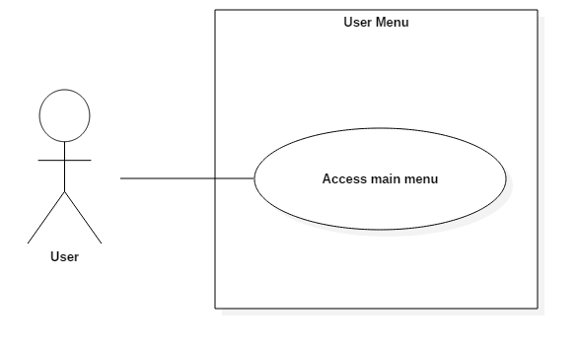

|  |  |
| --- | --- |
| Use Case Name | Loading of a main menu |
| Description | The user needs a main menu to access for a SkillCourt game. |
| Participating Actors | 1. User: SkillCourt Owner |
| Flow of Events | 1. The user has downloaded the app. 2. The user opens the app with the Icon 3. Application should load properly and display all buttons. |
| Alternative Flows | 1. User app does not load    1. System throws an exception. System ends |
| Entry Conditions | 1. User Has downloaded the app 2. User has clicked the icon |
| Exit Conditions | 1. Display is created. 2. Display is closed. 3. Display cannot be created. |

*Figure #201a - Use Case for Android Game Menu (653)*

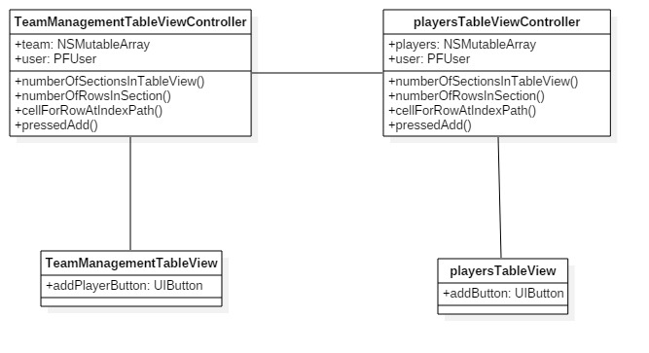

## 

*Figure #699c - class diagram- team (699)*

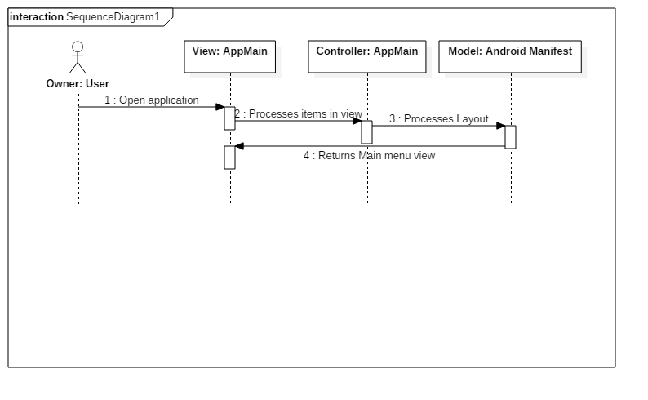

*Figure #201b - Sequence Diagram SkillCourt GUI Wizard (692)*

|  |  |
| --- | --- |
| Use Case Name | Standardized sequence format |
| Description | The system creates a standardized UML document with all the information of a sequence. |
| Participating Actors | 1. User: SkillCourt Owner |
| Flow of Events | 1. The SkillCourt Owner first provides all the needed information. This includes all the information about the grids, steps to be followed, and relevant data. 2. User is asked for grid information, first creating Grid objects with 'Rows and Columns to denote the size. One grid object per 'wall' in a skillCourt simulator or live demonstration.    * Rows    * Columns 3. With grids created, gridCommands can now be created as well. Grid Commands only affect a specific tile in a specific grid. They are denoted with these details.    * Name of grid affected    * Grid Row    * Grid Column    * Red, Green and Blue color values    * Command ID (Unique value per command) 4. Step 3 is repeated for the amount of tiles affected. 5. The system now creates Step objects. Which manage a single iteration of Skillcourt actions. This object contains certain details    * Duration (Amount of time in ms this step lasts)    * Interval (Amount of time in ms before a step begins)    * List of GridCommands 6. Step 3 and 4 are repeated for any subsequent Step objects 7. A SequenceFile object is created, where all the user information and sequence information resides. User fills in this information. Which is stored as a hashmap    * Author    * Sequence Name    * Game Type 8. The export function in SequenceFile object is used, the sequence is output in a universal serialized UML format. Only parameter needed is the filename. |
| Alternative Flows | 1. System discovers an error in the creation of the sequenceFile.    1. System discards object and throws error on creation 2. User provides invalid information for the creation of a sequenceFile object. IE: Negative Timings    1. Error is thrown. System does not proceed |
| Entry Conditions | 1. A sequence has been defined through user programming. |
| Exit Conditions | 1. The system maintains a proper layout of all objects necessary to execute a sequence. 2. A proper sequence object is created. 3. A physical export in proper sequence format is output. |

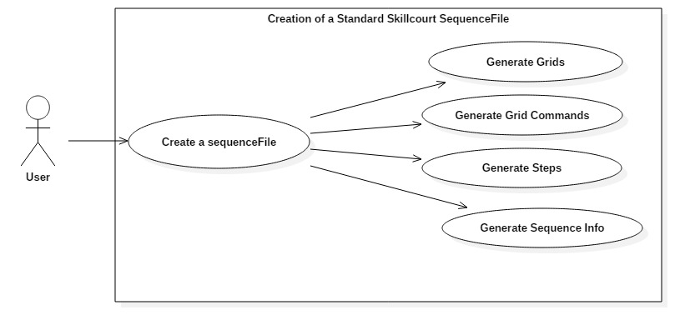

*Figure #202a - Use Case for creation of sequence standard (661)*

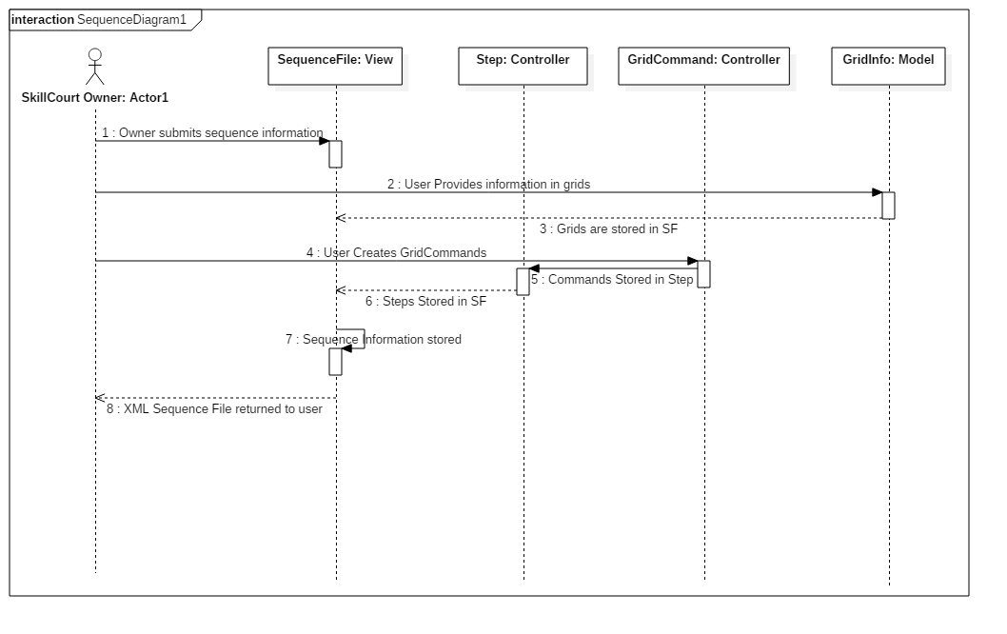

*Figure #202b - Sequence Diagram for creation of sequence standard (661)*

|  |  |
| --- | --- |
| Use Case Name | Interpret Sequence Format |
| Description | The system creates a sequence object from file |
| Participating Actors | 1. User: SkillCourt Owner |
| Flow of Events | 1. The SkillCourt Owner provides XML file path. 2. The path is provided to AuxFunctions, this class processes the file and if valid creates an object. 3. A sequence object is created and available for use. |
| Alternative Flows | 1. System discovers an error in the creation of the sequenceFile.    1. System discards object and throws error on creation 2. User provides invalid information for the creation of a sequenceFile object. IE: Negative Timings    1. Error is thrown. System does not proceed |
| Entry Conditions | 1. A sequence has been created, and saved as XML. 2. User has provided a path for the file. |
| Exit Conditions | 1. The system maintains a proper layout of all objects necessary to execute a sequence. 2. A proper sequence object is imported created. |

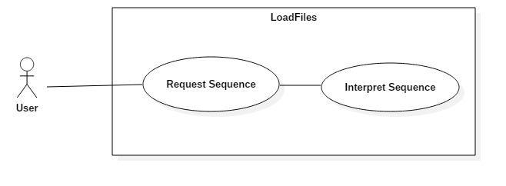

*Figure #203a - Use Case Diagram for Interpreter (655)*

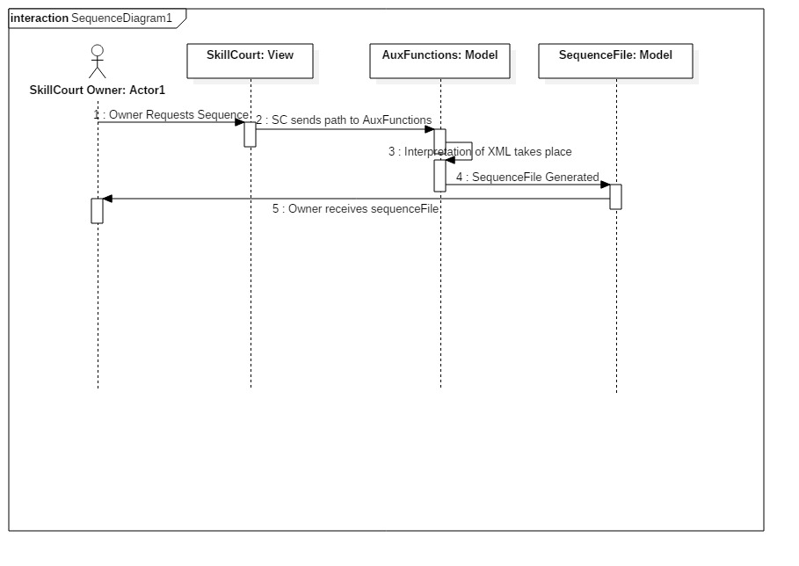

*Figure #203b - Sequence Diagram for Interpreter (655)*

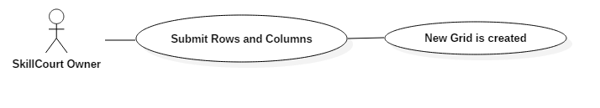

*Figure #204a - Use Case Sized Grid Process (672)*

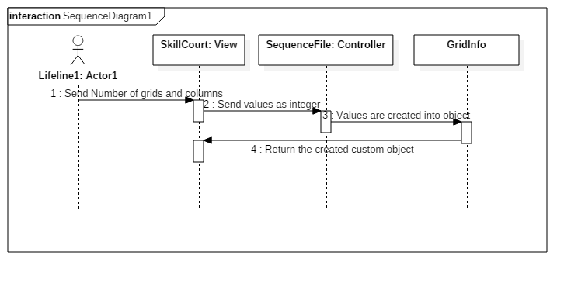

*Figure #204b - Sequence Sized Grid Process (672)*

|  |  |
| --- | --- |
| Use Case Name | Communication to Multiple Pads |
| Description | The system needs a way to communicate to multiple pads at once. For the sake of skillcourt games. |
| Participating Actors | 1. User: SkillCourt Owner |
| Flow of Events | 1. The SkillCourt Owner first provides all the needed information. Including the Baud, COM port, and related pad. 2. User is asked for Communication Information. This individual for every created pad.    * Port    * Baud    * Serial    * Related Pad 3. With this connection entered, the port can begin communication once it is established, 4. Variables for use set on default to false. |
| Alternative Flows | 1. System discovers an error in the creation of the serial port.    1. System discards object and throws a communication exception 2. User provides invalid information for the creation of a pad handler object.    1. Error is thrown. System does not proceed |
| Entry Conditions | 1. A pad has been created and communication to that pad is needed. |
| Exit Conditions | 1. Communication is established. 2. A communication object is created. |

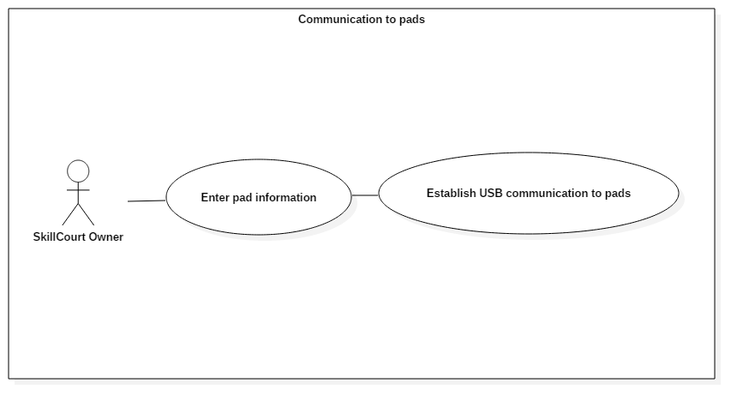

*Figure #205a - Use Case Diagram for Serial Communication (676)*

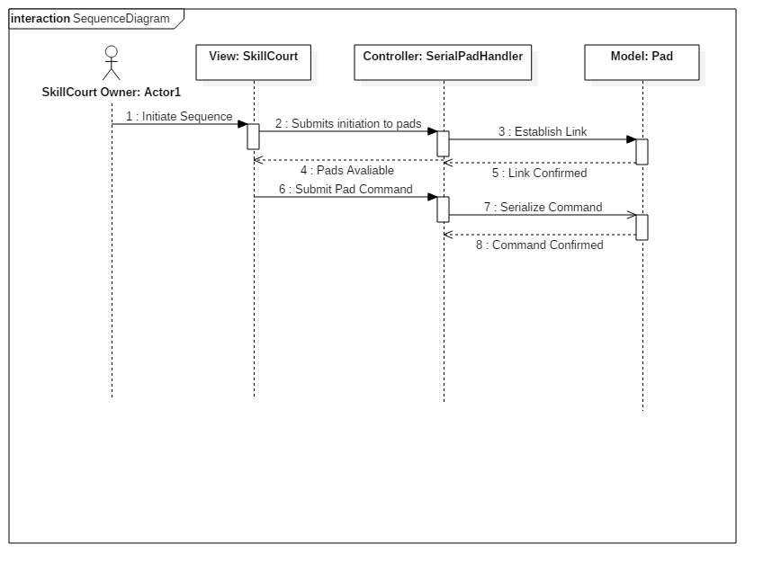

*Figure #205b - Sequence Diagram for Serial Communication (676)*

|  |  |
| --- | --- |
| Use Case Name | Loading and display of custom views |
| Description | The system needs a way for users to interact with custom-sized grids. Outside the former 5x5 parameters. |
| Participating Actors | 1. User: SkillCourt Owner |
| Flow of Events | 1. The SkillCourt Owner first provides the GridInfo class object with the proper information. 2. XmlGrid object is created, it requires the following attributes.    * Name    * Rows    * Columns 3. Xml Grid takes in a GridInfo object, it will automatically generate the proper Xml output file and return a string 4. A basic nifty object is created, this object will use the xml output 5. The proper grid screen displays for the user. |
| Alternative Flows | 1. System discovers an error in the creation of the GUI    1. System discards object and throws an exception. System ends 2. User provides invalid information for the creation of a GridInfo object    1. Error is thrown. System does not proceed |
| Entry Conditions | 1. GridInfo object for a specified grid has been created 2. Name, rows, and columns have been assigned |
| Exit Conditions | 1. Display is created. 2. Display is closed. 3. Display cannot be created. |

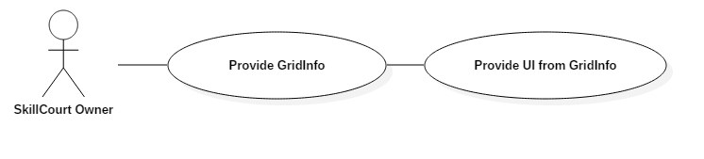

*Figure #206a - Use Case Diagram Custom Grid View (683)*

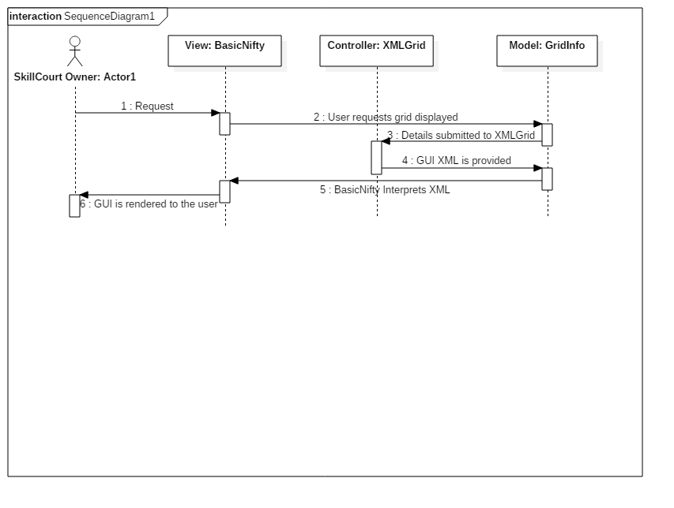

*Figure #206b - Sequence Diagram Custom Grid View (683)*

|  |  |
| --- | --- |
| Use Case Name | Sequencer UI |
| Description | The system needs a way for users to create sequences in an easy step-by-step way. |
| Participating Actors | 1. User: SkillCourt Owner |
| Flow of Events | 1. The SkillCourt Owner first will open the program. 2. A sequence object is starting to become created and includes    * Name and Sequence Name    * Grids    * Steps 3. Each Step will ask for. Duration and interval, then create grid commands 4. Once the sequence has been created it can be requested in the ‘load’ section. 5. Program can be quit, closing all serial connections. |
| Alternative Flows | 1. System discovers an error in finding the file    1. System discards object and throws an exception. System ends 2. User provides invalid information for sequence exports.    1. Error is thrown. System does not proceed |
| Entry Conditions | 1. User has a skillCourt connected to the computer. |
| Exit Conditions | 1. File is output as XML 2. Program is ended. 3. Sequence has been executed. |

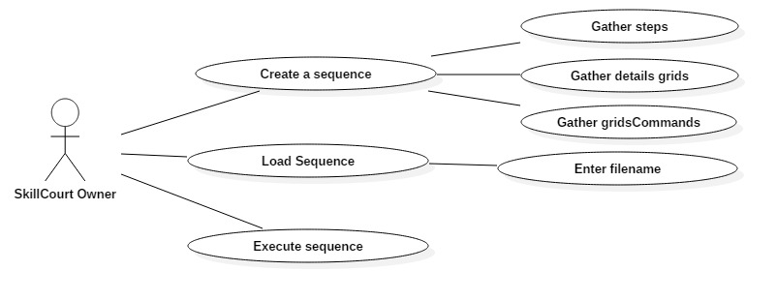

*Figure #207a - Use Case Diagram SkillCourt GUI Wizard (692)*



*Figure #207b - Sequence Diagram SkillCourt GUI Wizard (692)*

|  |  |
| --- | --- |
| **A user should be able to register to the SkillCourt system** | |
| ***Date Modified: 2/01/2016*** | |
| ID: | SK-001 |
| Actor: | Any user |
| Preconditions: | User is not registered to the system |
| Description : | User enters required info in register view  User presses register button  System checks if user already exists  If not, user is saved to database |
| Post-conditions: | User will be registered to the ysytem |
| Alternative courses of action: | User may never register to the system or cancel the action |
| Exceptions: | User may cancel process |
| Related Use Cases: | Registered user must be able to login to the system |
| Decision Support: | *Frequency*: On average a new user will register once every week    *Criticality*: strong. It is mandatory to have a register option    *Risk*: none |
| Constraints: | · Usability    o No previous Training Time.      · Reliability    o should always register a user if needed  · Performance    o Response time should be less than 2 seconds    · Supportability    o the registration view must be clearly visible on any compatible version of iOS |

*Figure #654a - Use case diagram- register (692)*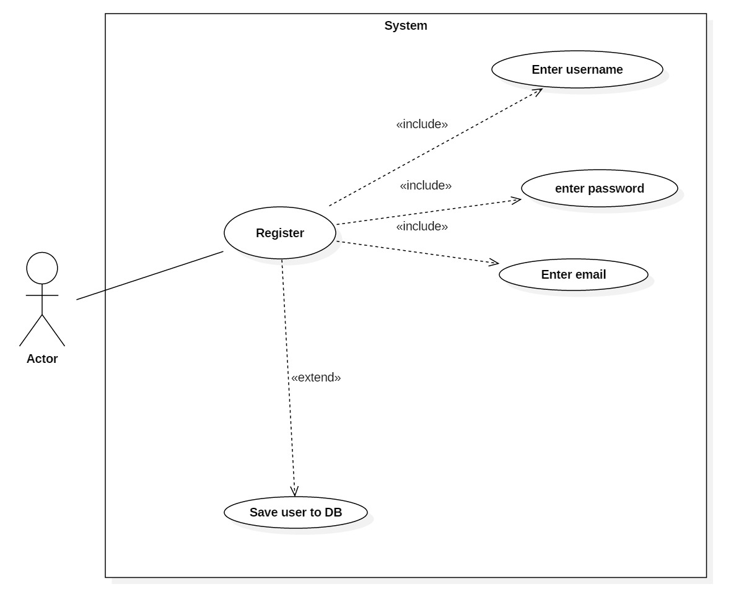

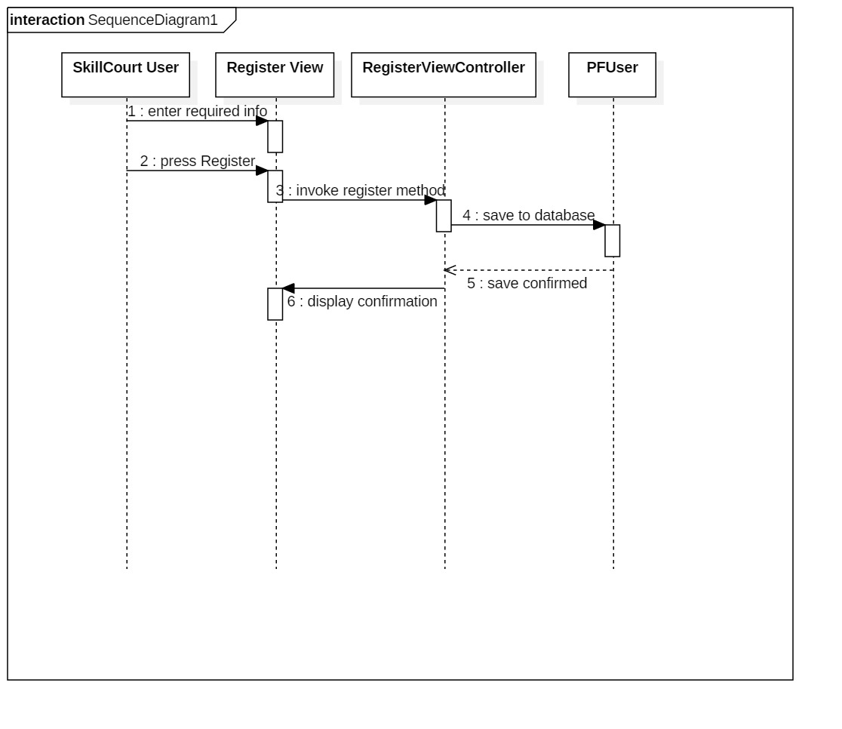

*Figure #654b - Sequence Diagram-register (654)*

|  |  |
| --- | --- |
| **A user should be able to register to the SkillCourt system** | |
| ***Date Modified: 2/01/2016*** | |
| ID: | SK-002 |
| Actor: | Registered user |
| Preconditions: | User is registered to the system  User is at login page |
| Description : | User enters required info in login view  User presses login button  System checks information  If it is correct, system logs in to database also |
| Post-conditions: | User will be at team management page |
| Alternative courses of action: | User may not login |
| Exceptions: | Incorrect info will fail at login |
| Related Use Cases: | user must be able to register to the system |
| Decision Support: | *Frequency*: On average a new user will login once every day  *Criticality*: strong. It is mandatory to have a login option    *Risk*: high critical for security and personalization |
| Constraints: | · Usability    o No previous Training Time.      · Reliability    o should always login a user if needed  · Performance    o Response time should be less than 2 seconds    · Supportability    o the login view must be clearly visible on any compatible version of iOS |

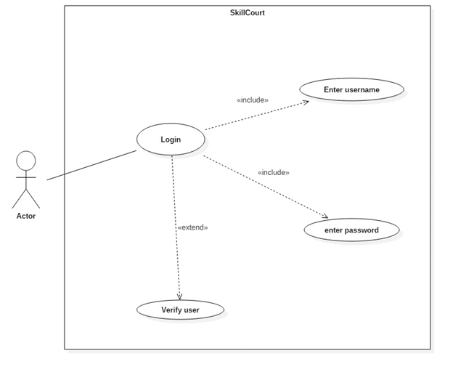

*Figure #655a - Use case diagram- login (655)*

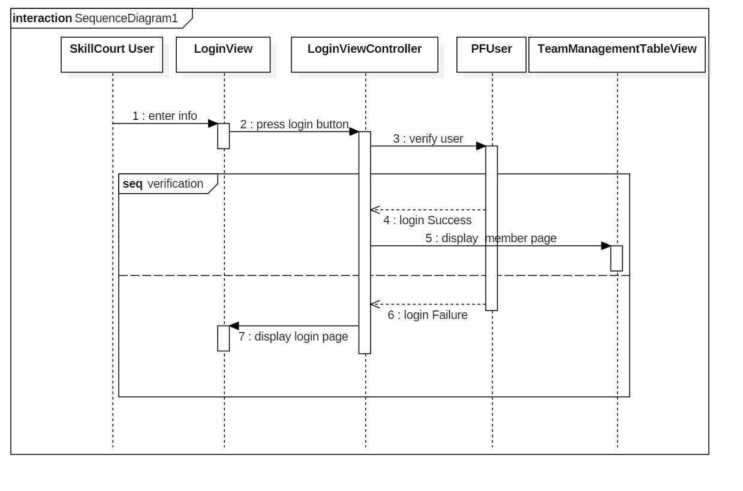

*Figure #655b - sequence diagram- login (655)*

|  |  |
| --- | --- |
| **A registered user should be able to save user info locally** | |
| ***Date Modified: 03/21/2016*** | |
| ID: | SK-005 |
| Actor: | Registered user |
| Preconditions: | User is registered to the system  User has successfully logged on to the system  Application is closed |
| Description : | Registered user logs into the system  The system will get all user details  The system will save the details locally  The system will remember last user details offline |
| Post-conditions: | Profile page will show info when offline |
| Alternative courses of action: | User may logout after logging in |
| Exceptions: | Nothing will be saved if login fails |
| Related Use Cases: | Registered user must be able to login to the system |
| Decision Support: | *Frequency*: On average a Registered user will login once every day    *Criticality*: strong. It is mandatory to have persistent data management    *Risk*: moderate. Many algorithms to implement |
| Constraints: | · Usability    o No previous Training Time.      · Reliability    o Should always have the last user details saved unless user logs out    · Performance    o Response time should be less than 2 seconds    · Supportability    o the Profile tab must be clearly visible on any compatible version of ios |

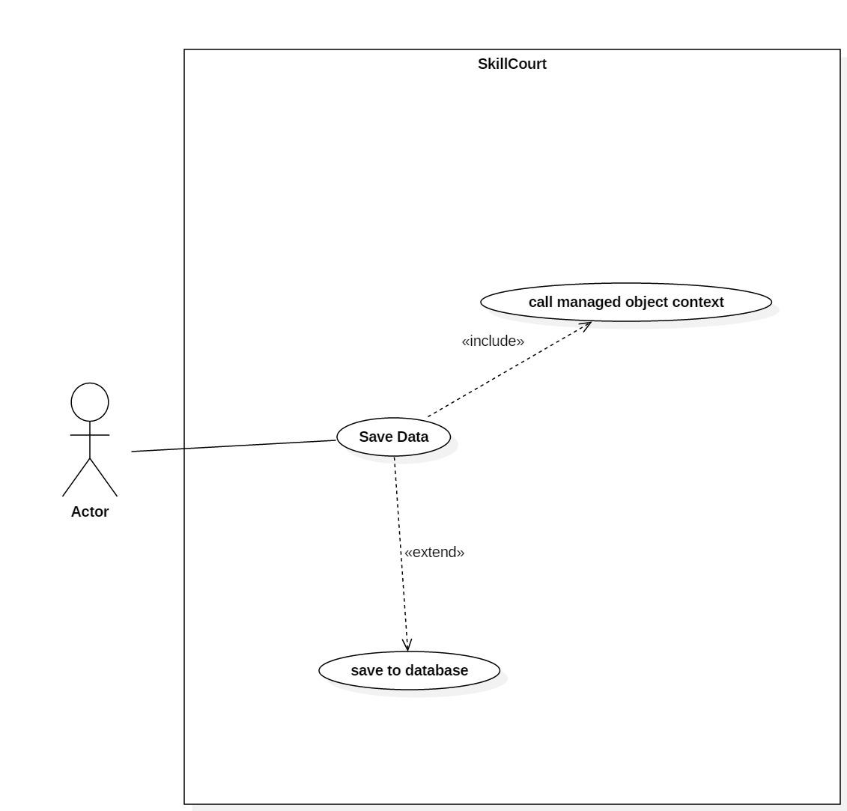

*Figure #675a - Use case diagram- login (675)*

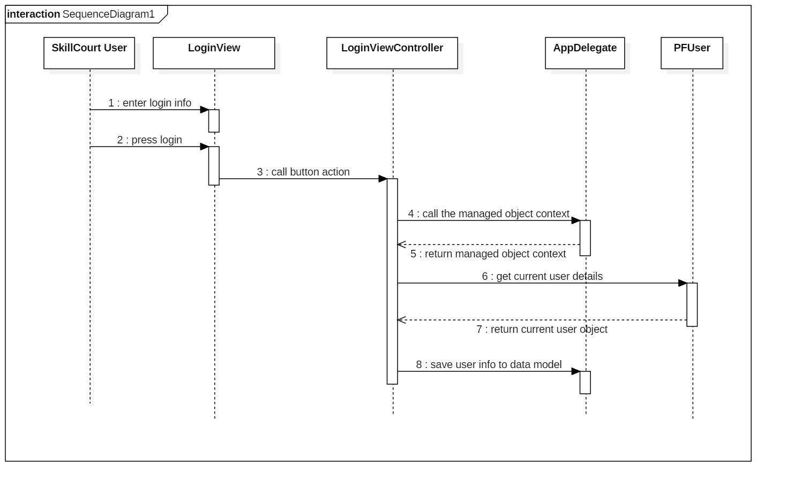

*Figure #675b -sequence diagram-save (675)*

|  |  |
| --- | --- |
| **A user should be able to logout of the system** | |
| ***Date Modified: 04/04/2016*** | |
| ID: | SK-008 |
| Actor: | Registered user |
| Preconditions: | User is already logged in to the system  User is at the settings tab within the application |
| Description : | User presses the logout button  System logs out of the parse database  System displays the loginView |
| Post-conditions: | [PFUser currentUser] will be empty  Login pages will be displayed |
| Alternative courses of action: | User may never logout to the system |
| Exceptions: | None |
| Related Use Cases: | Registered user must be able to login to the system |
| Decision Support: | *Frequency*: On average a Registered user will logout once every day    *Criticality*: strong. It is mandatory to have a logout option    *Risk*: none |
| Constraints: | · Usability    o No previous Training Time.      · Reliability    o should always logout if needed  · Performance    o Response time should be less than 2 seconds    · Supportability    o the application settings must be clearly visible on any compatible version of ios |

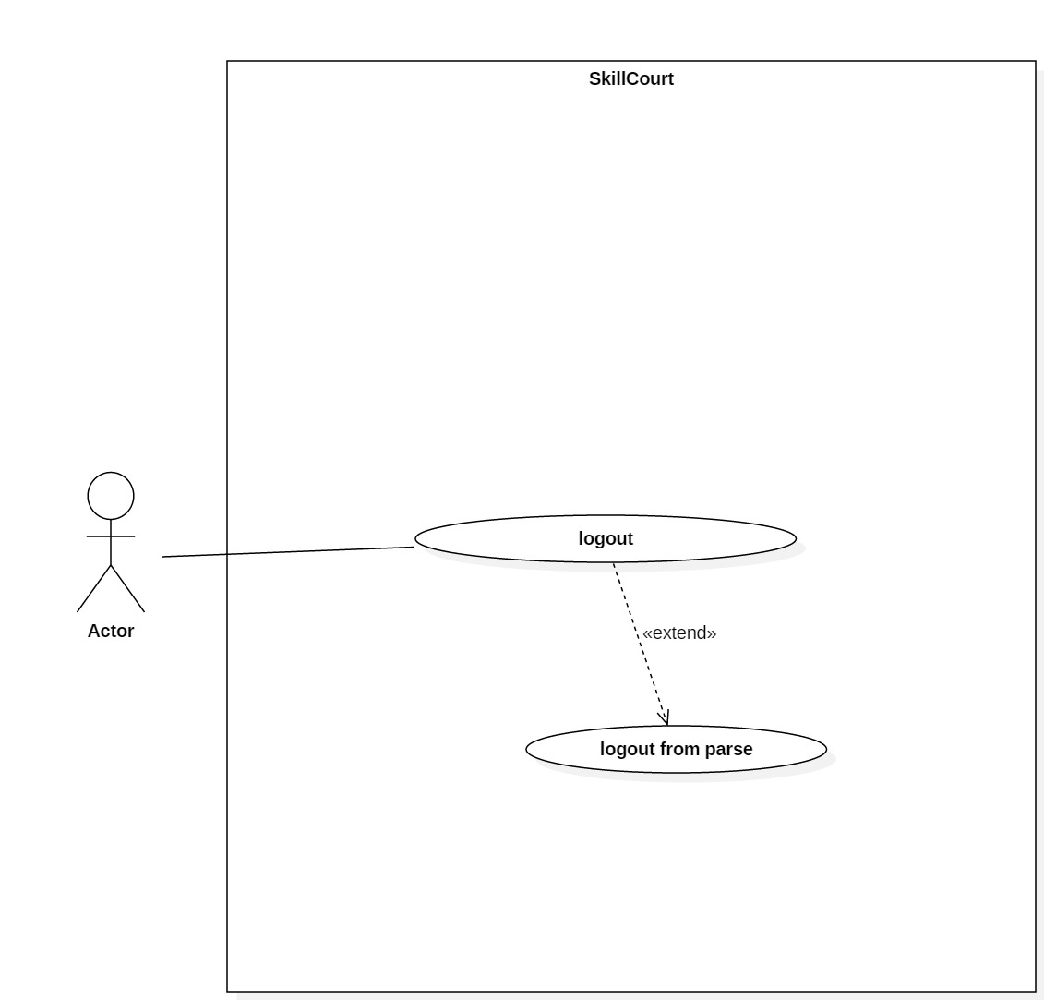

*Figure #682a - Use case diagram- logout (682)*

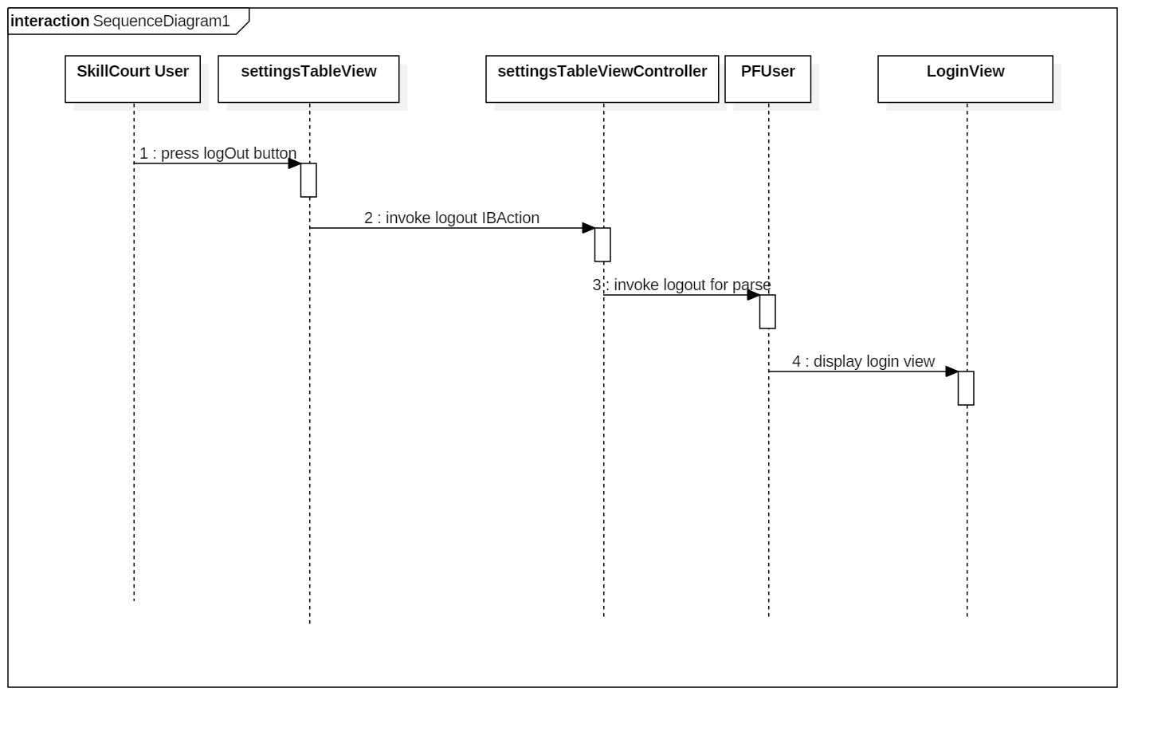

*Figure #682b - Use case diagram- logout (682)*

|  |  |
| --- | --- |
| user must be able to create a sequence file from the iOS device | |
| ***Date Modified: 04/13/2016*** | |
| ID: | SK-011 |
| Actor: | A registered user |
| Preconditions: | User is already logged in to the system  User is at the drill management tab within the application |
| Description : | User presses the add button  User enters info  Syystem saves info  System creates xml file |
| Post-conditions: | Xml file should have been created |
| Alternative courses of action: | Bad info causes creation of no xml files |
| Exceptions: | Bad encoding of file |
| Related Use Cases: | none |
| Decision Support: | *Frequency*: On average a Registered user will create a sequence once every week    *Criticality*: strong. It is mandatory to have a sequence creation process    *Risk*: moderate, xml file must be exactly as the java version |
| Constraints: | · Usability    o No previous Training Time.      · Reliability    o should always create file if needed  · Performance    o Response time should be less than 2 seconds    · Supportability    o the process must be clearly visible on any compatible version of ios |

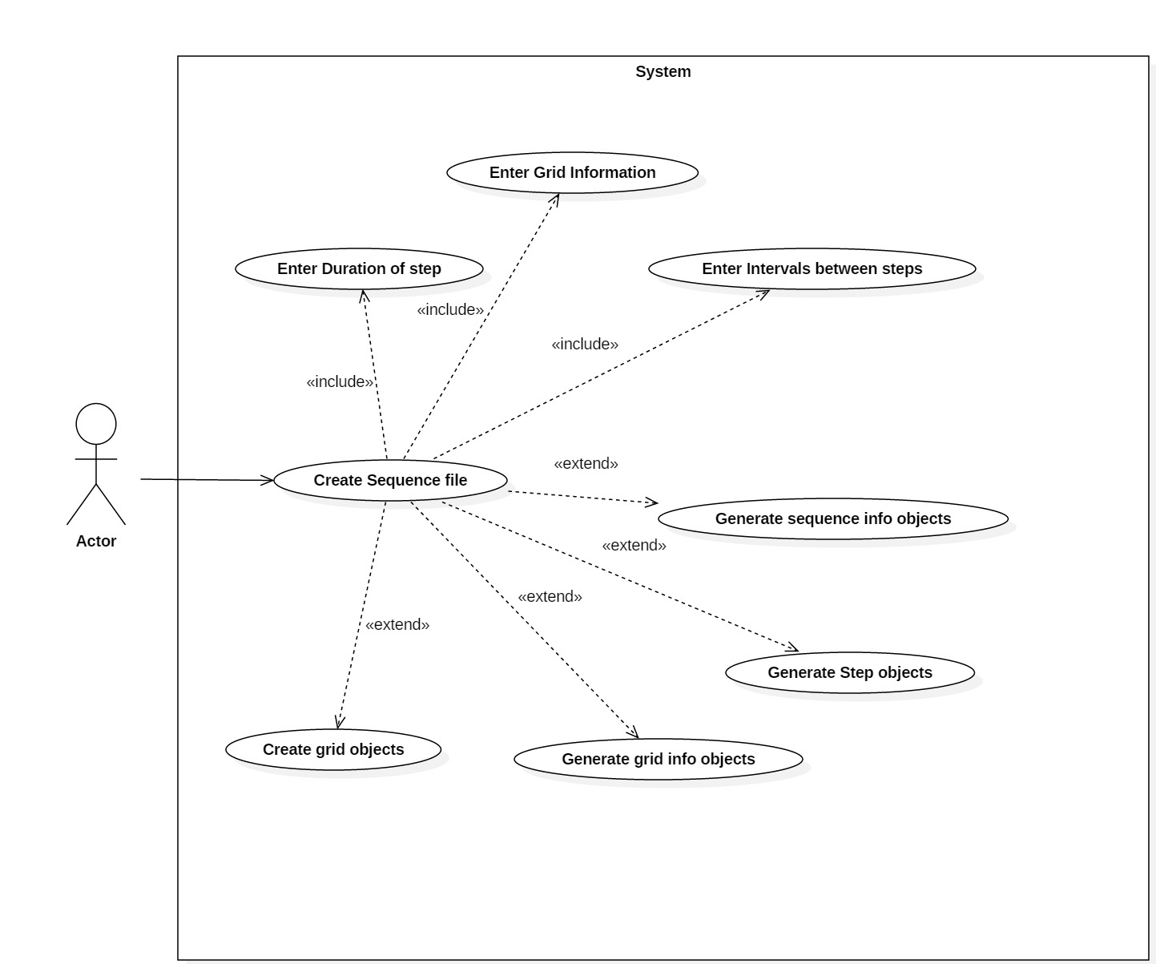

*Figure #687a - Use case diagram- sequence (687)*

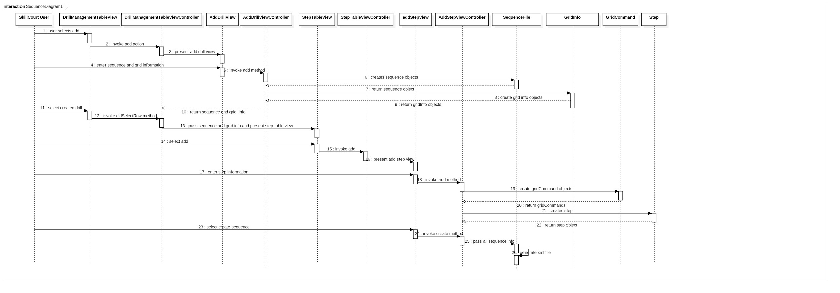

*Figure #687b - sequence diagram- sequence (687)*

|  |  |
| --- | --- |
| user must be able to connect the SkillCourt App to the SkillCourt Pads through bluetooth | |
| ***Date Modified: 04/13/2016*** | |
| ID: | SK-012 |
| Actor: | A registered user |
| Preconditions: | User is already logged in to the system  User is at the SkillCourt tab within the application |
| Description : | User presses the Connect button  App connects to the bluetooth if present  Bluetooth connected and waiting for messages |
| Post-conditions: | Central will connect to peripheral |
| Alternative courses of action: | User may cancel of not connect |
| Exceptions: | App will not connect if peripheral is not present |
| Related Use Cases: | none |
| Decision Support: | *Frequency*: On average a Registered user will connect to bluetooth 3 times per week    *Criticality*: strong. It is mandatory to have bluetooth connection    *Risk*: high, must have bluetooth connection to run a sequence from the app |
| Constraints: | · Usability    o No previous Training Time.      · Reliability    o should always connect file if needed  · Performance    o Response time should be less than 2 seconds    · Supportability    o the process must be clearly visible on any compatible version of ios |

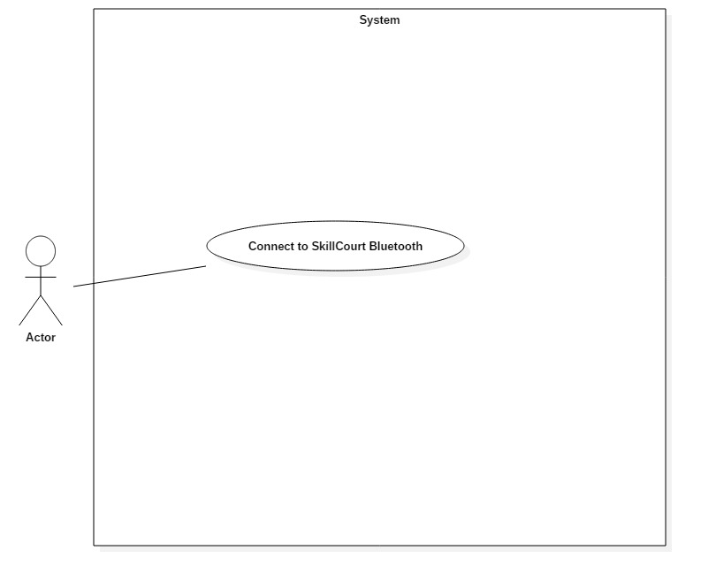

*Figure #696a - Use case diagram- bluetooth (696)*

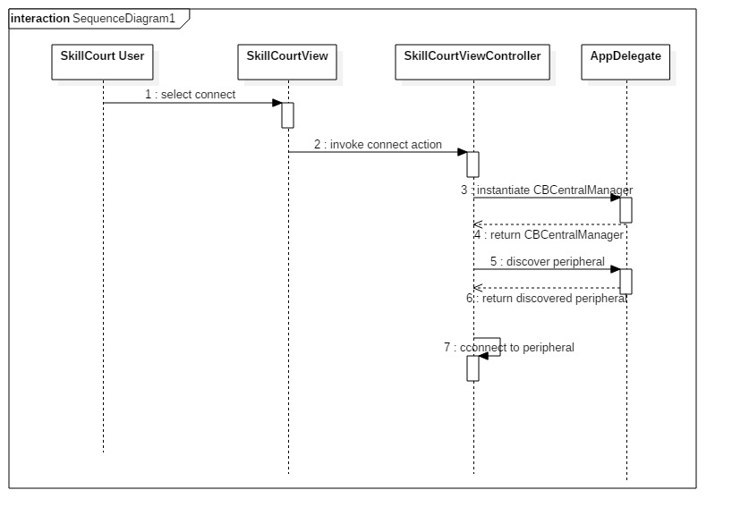

*Figure #696b - sequence diagram- bluetooth (696)*

|  |  |
| --- | --- |
| user must be able to view and edit their team members | |
| ***Date Modified: 05/02/2016*** | |
| ID: | SK-013 |
| Actor: | A registered user |
| Preconditions: | User is already logged in to the system  User is at the teamManagement tab within the application |
| Description : | User presses the add player button  App displays available players and stats  User selects player  Player is placed on users team |
| Post-conditions: | Player will be in team list |
| Alternative courses of action: | User may cancel process |
| Exceptions: | No list will appear if no players exist |
| Related Use Cases: | none |
| Decision Support: | *Frequency*: On average a Registered user will manage their team everyday.    *Criticality*: moderate; needed for reviewing stats    *Risk*: moderate, does not hinder the apps functionality |
| Constraints: | · Usability    o No previous Training Time.      · Reliability    o should always add a player if needed  · Performance    o Response time should be less than 2 seconds    · Supportability    o the process must be clearly visible on any compatible version of ios |

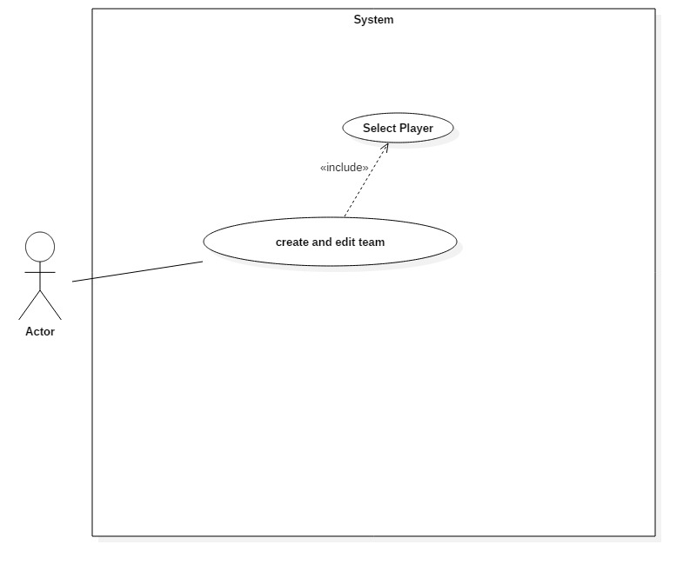

*Figure #699a - use case diagram- team (699)*

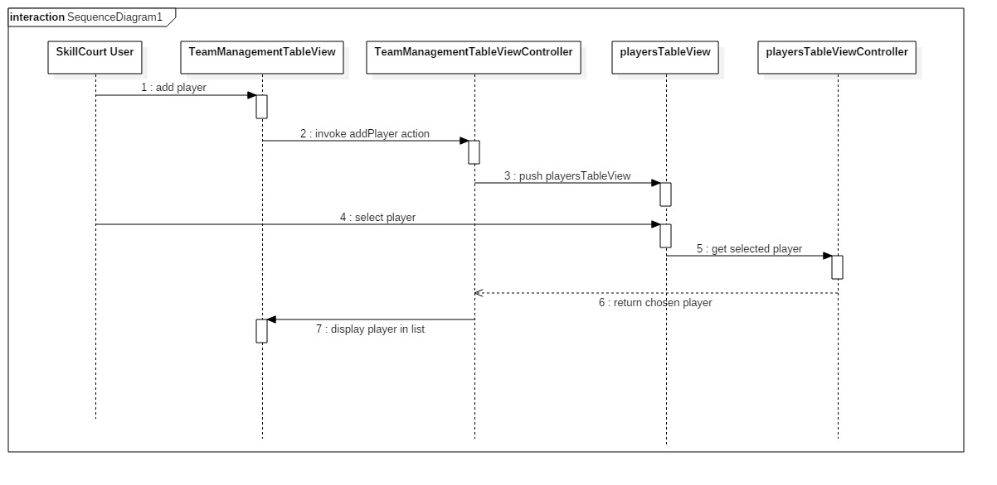

*Figure #699b - class diagram- team (699)*

## Appendix B - User Interface Design

Screenshots of user interfaces

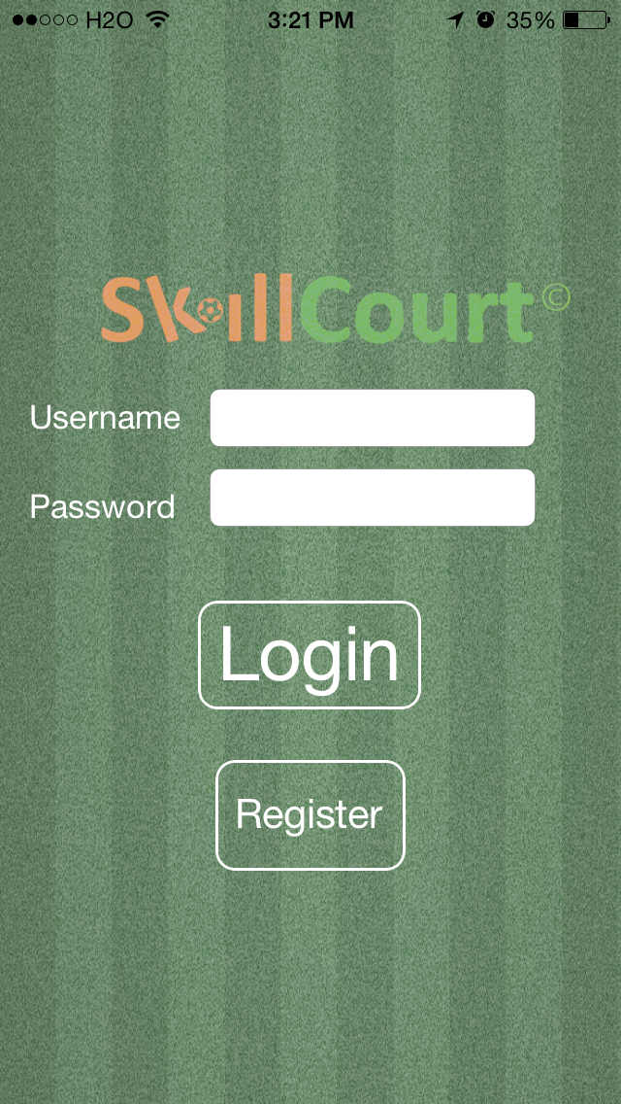

*Figure SC-001 -login screen*

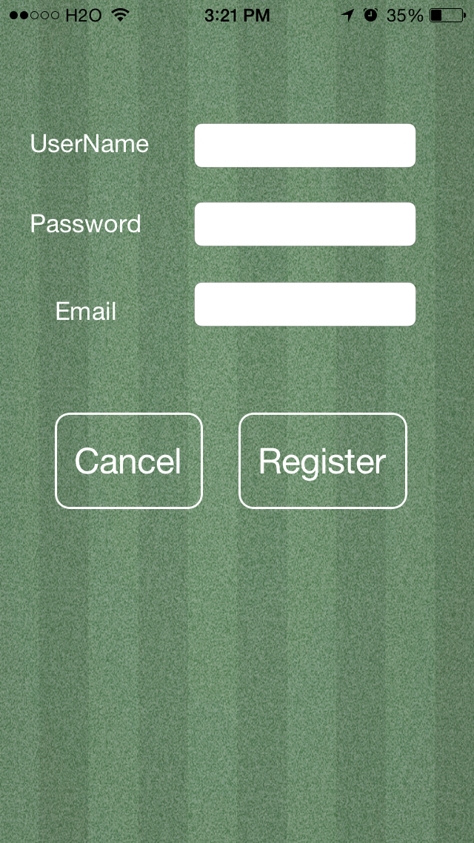

*Figure SC-002 -register screen*

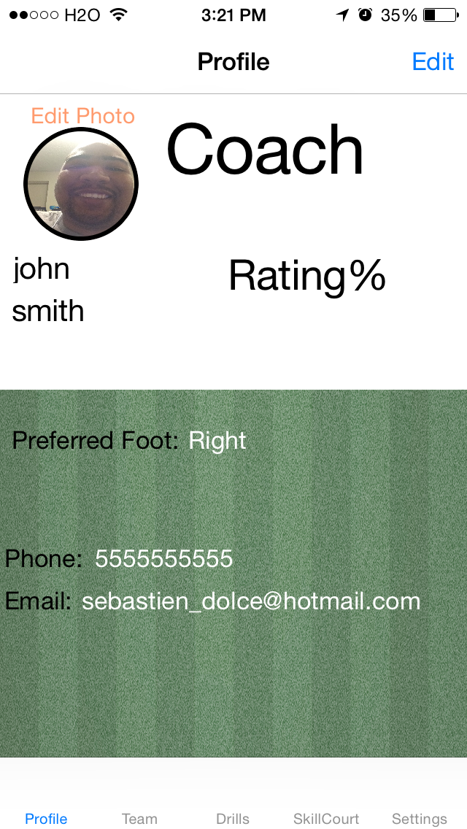

*Figure SC-003 -profile screen*

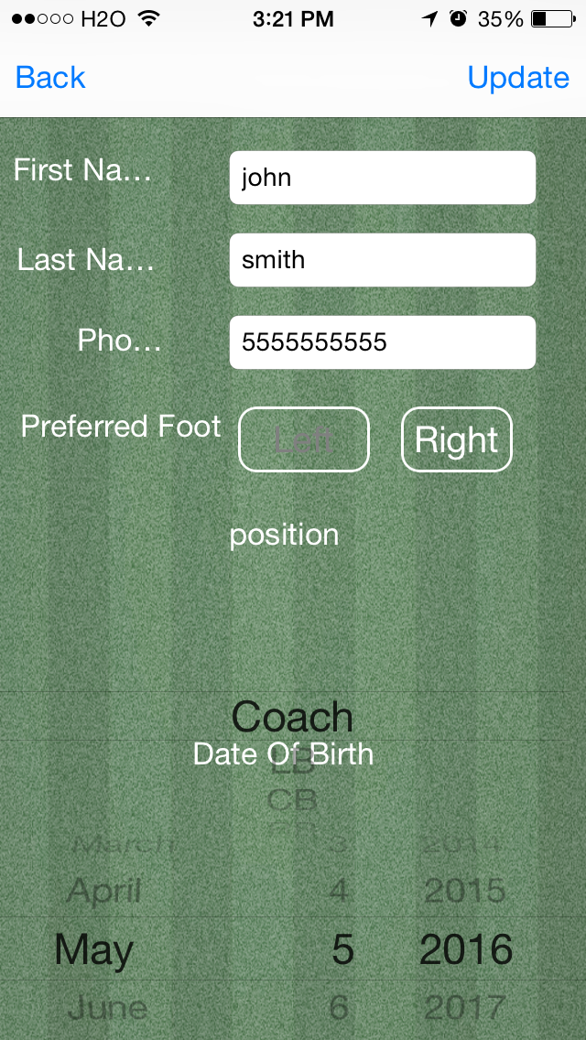

*Figure SC-004 -edit profile screen*

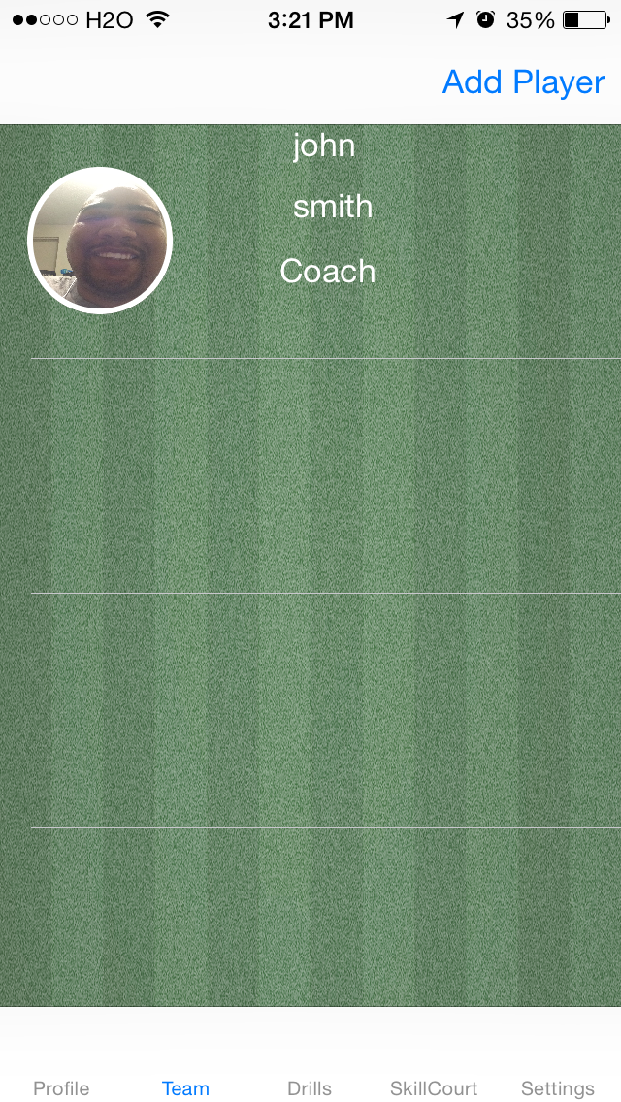

*Figure SC-005 -team screen*

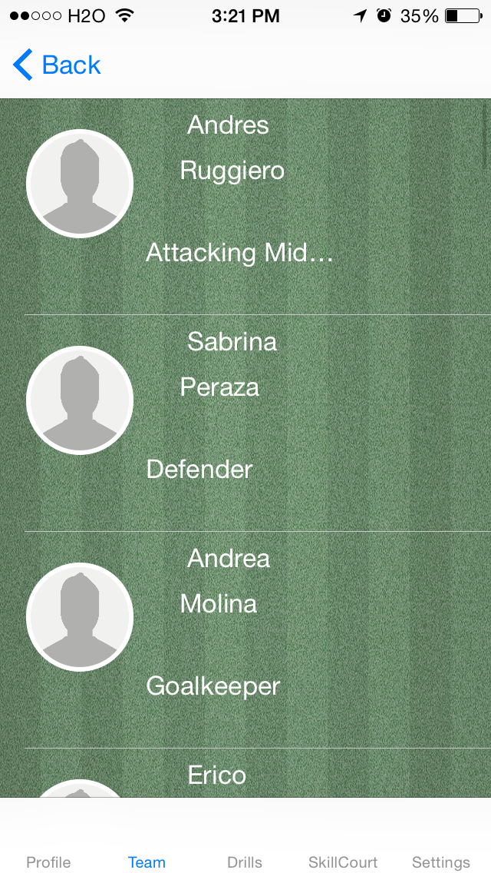

*Figure SC-006 -add player screen*

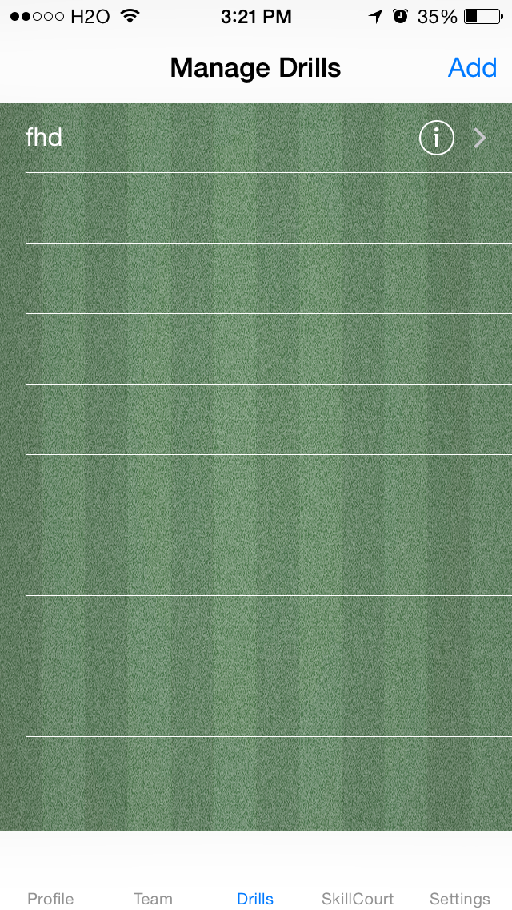

*Figure SC-007 -drills screen*

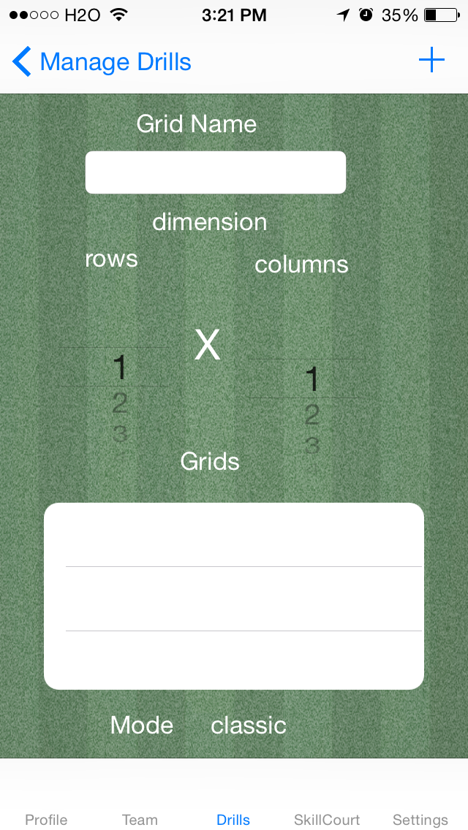

*Figure SC-008 -grids screen*

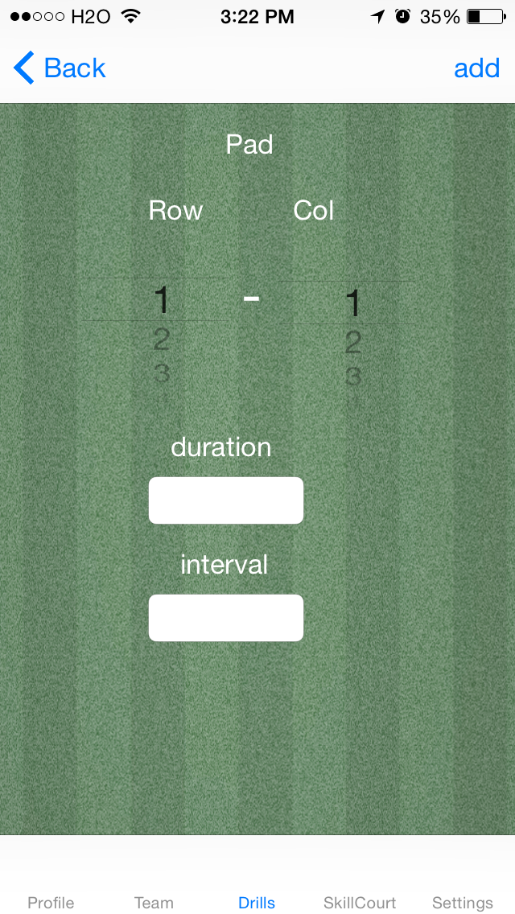

*Figure SC-009 -add step screen*

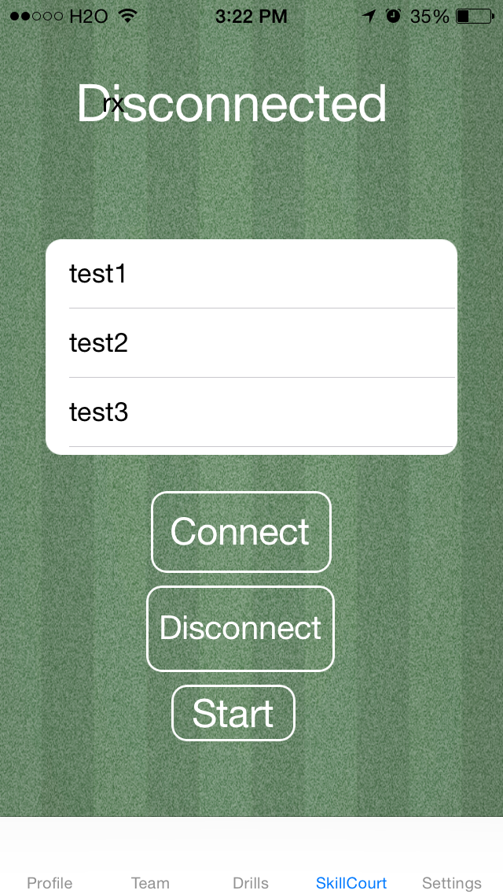

*Figure SC-010 -bluetooth screen*

*Figure SC-011 -settings screen*

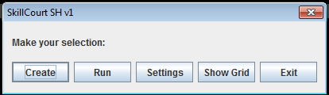

*Fig SH01 - SkillCourt SH Gui*

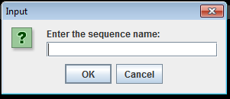

*Fig SH02 - SkillCourt SH Gui - Create a sequence*

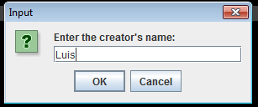

*Fig SH03 - SkillCourt SH Gui - Create a sequence*

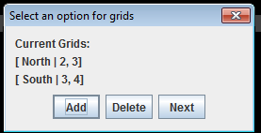

*Fig SH04 - SkillCourt SH Gui - Create a sequence*

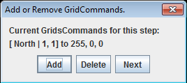

*Fig SH05 - SkillCourt SH Gui - View grid Commands*

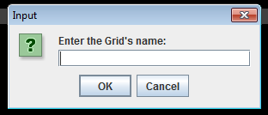

*Fig SH06 - SkillCourt SH Gui - add grid commands*

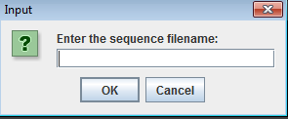

*Fig SH06 - SkillCourt SH Gui - Load a sequence*

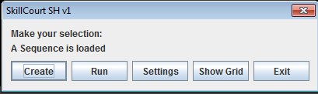

*Fig SH07 - SkillCourt SH Gui - Loaded sequence GUI*

## Appendix C - Sprint Review Reports

**Sprint 1 Report**

Date: 2/10/2016

Attendees:Gumi Traustason,roberto, Wu, Tang , Jordan, Sebastien Dolce, Luis Puche

**Discussed Topics:**

* User Registration
* Android game main menu.

**Rejected user stories**

* User Story 653 : Android game main menu
  + Reason for rejection:
    - Decided to focus on pad manipulation than android application
    - Needed a better filesystem for sequences (needed attention)

**Sprint 2 Report**

Date: 2/24/2016

Attendees:Gumi Traustason, Sebastien Dolce, Luis Puche

**Discussed Topics:**

* User Login
* Create SkillCourt sequence standard

**Rejected user stories**

* User Story 661 : SkillCourt Sequence Standard
  + Reason for rejection:
    - Needed to finish GUI components

**Sprint 3 Report**

Date: 3/10/2016

Attendees:Gumi Traustason,roberto, Wu, Tang , Jordan, Sebastien Dolce, Luis Puche

**Discussed Topics:**

* User view and edit profile
* Interpret and load sequences.

**Rejected user stories**

* N/A

**Sprint 4 Report**

Date: 3/31/2016

Attendees:Gumi Traustason,roberto, Wu, Tang , Jordan, Sebastien Dolce, Luis Puche

**Discussed Topics:**

* Persistent Data iOS
* Create custom-sized grid

**Rejected user stories**

* User Story 672
  + Reason for rejection:
    - Not completely integrated into basic sequence file

**t**

**Sprint 5 Report**

**Discussed Topics:**

* User Registration
* Android game main menu.

**Rejected user stories**

* User Story 653 : Android game main menu
  + Reason for rejection:
    - Decided to focus on pad manipulation than android application
    - Needed a better filesystem for sequences (needed attention)

**Sprint 6 Report**

Date: 4/14/2016

Attendees:Gumi Traustason,roberto, Wu, Tang , Jordan, Sebastien Dolce, Luis Puche

**Discussed Topics:**

* Implement save user settings
* iOS LogOut
* Communication to multiple pads

**Rejected user stories**

* N/A

**Sprint 7 Report**

Date: 4/26/2016

Attendees:Gumi Traustason,roberto, Wu, Tang , Jordan, Sebastien Dolce, Luis Puche

**Discussed Topics:**

* Sequence creation process
* Custom grid view

**Rejected user stories**

* N/A

## Appendix D - Sprint Retrospective Reports

**Sprint 1 Retrospective**

Date: 1/20/2016

Attendees:Gumi Traustason, Jaime Borras, Sebastien Dolce, Luis Puche

**Discussed Topics**

What went wrong?

* The velocity estimation was correct at 0 because we needed more research on the current version
* The points estimation was correct at 0 because we needed more research on the current version

What went right?

* On schedule
* Have user stories to work on

How to address the issues in the next sprint?

* How to improve the process?
  + Meet with entire team including engineering team
* How to improve the product?
  + Have an iOS app

**Sprint 2 Retrospective**

Date: 2/10/2016

Attendees:Gumi Traustason,roberto, Wu, Tang , Jordan, Sebastien Dolce, Luis Puche

**Discussed Topics:**

What went wrong?

* Inexperience with user story documentation caused for more time to be used
* Hardware problems

What went right?

* On schedule
* All project are started and up with demos available

How to address the issues in the next sprint?

* How to improve the process?
  + Integrate parse in iOS app
  + Familiarize and borrow hardware
* How to improve the product?
  + Create sequence standard

**Sprint 3 Retrospective**

Date: 2/24/2016

Attendees:Gumi Traustason, Sebastien Dolce, Luis Puche

**Discussed Topics**

What went wrong?

* Inexperience with user story documentation caused wrong points estimation

What went right?

* On schedule

How to address the issues in the next sprint?

* How to improve the process?
  + Have user profiles
* How to improve the product?
  + Get more pads

**Sprint 4 Retrospective**

Date: 3/10/2016

Attendees:Gumi Traustason,roberto, Wu, Tang , Jordan, Sebastien Dolce, Luis Puche

**Discussed Topics**

What went wrong?

* N/A

What went right?

* On schedule
* Liked both engineers’ works

How to address the issues in the next sprint?

* How to improve the process?
  + Not having the need to login everytime
  + Limitations with Processing
* How to improve the product?
  + More pads
  + Develop a centralized processor.

**Sprint 5 Retrospective**

Date: 3/31/2016

Attendees:Gumi Traustason,roberto, Wu, Tang , Jordan, Sebastien Dolce, Luis Puche

**Discussed Topics**

What went wrong?

* Need a settings option to decide whether it should save user info

What went right?

* On schedule
* Demo works with old implementation

How to address the issues in the next sprint?

* How to improve the process?
  + Need the settings bundle for iOS
  + Communication to multiple pads not there.
* How to improve the product?
  + Reference each pad separately
  + Re-work communication in current system,

**Sprint 6 Retrospective**

Date: 4/14/2016

Attendees:Gumi Traustason,roberto, Wu, Tang , Jordan, Sebastien Dolce, Luis Puche

**Discussed Topics**

What went wrong?

* N/A

What went right?

* On schedule
* All pads working
* Able to run sequences on multiple pads

How to address the issues in the next sprint?

* How to improve the process?
  + Create a sequence from iOS device
* How to improve the product?
  + Have user chose how big their SkillCourt is. Multiple grids as well

**Sprint 7 Retrospective**

Date: 4/26/2016

Attendees:Gumi Traustason,roberto, Wu, Tang , Jordan, Sebastien Dolce, Luis Puche

**Discussed Topics**

What went wrong?

* Sequence creation on ios demo delayed because Mac will not recognize my iPhone, need a system restore

What went right?

* Demo will come soon
* Have full demo of skillCourt working

How to address the issues in the next sprint?

* How to improve the process?
  + iOS Bluetooth
* How to improve the product?
  + Integrate all systems

# References

***For Simulators***

1. Processing IDE 3.0.2 [http://processing.org/](https://processing.org/)
2. Netbeans IDE 8.0.2 http://netbeans.org/
3. RXTX Java Library http://rxtx.qbang.org/
4. LWJGL 2.0 http://www.lwjgl.org/
5. Nifty GUI 1.4 http://github.com/nifty-gui/nifty-gui/

***For Hardware***

1. Arduino 1.6.8 http://www.arduino.cc/
2. Notepad++ 6.9 http://notepad-plus-plus.org/
3. Android Studio 2.0 http://developer.android.com/

Miscellaneous

1. Stack Overflow (For Guidance) http://stackoverflow.com/